Year 9 |  | Volume and SA of Prisms and Cylinders | Non Calculator
Skills and Knowledge Assessed:  - Solve problems involving the surface area and volume of right prisms (ACMMG218)  - Calculate the surface area and volume of cylinders and solve related problems (ACMMG217)  - Solve problems involving surface area and volume for a range of prisms, cylinders and composite solids (ACMMG242) |  |  | Name_________________
Section 1 Short Answer Section
Write all working and answers in the spaces provided on this test paper.

What is the volume of the rectangular prism?

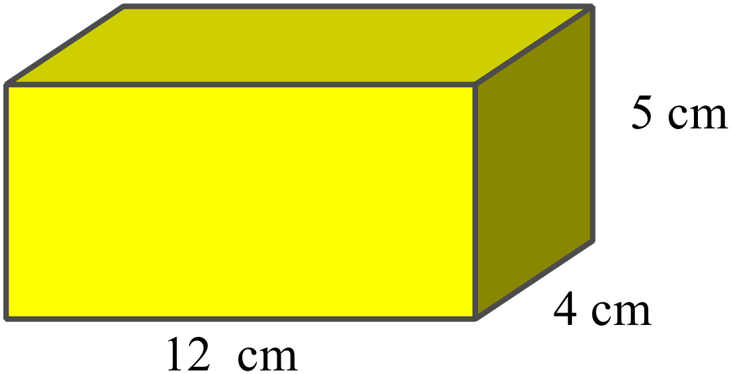

……………………………………………

…………………………………………....

…………………………………………….
This rectangular prism has a volume of 1 200 m².
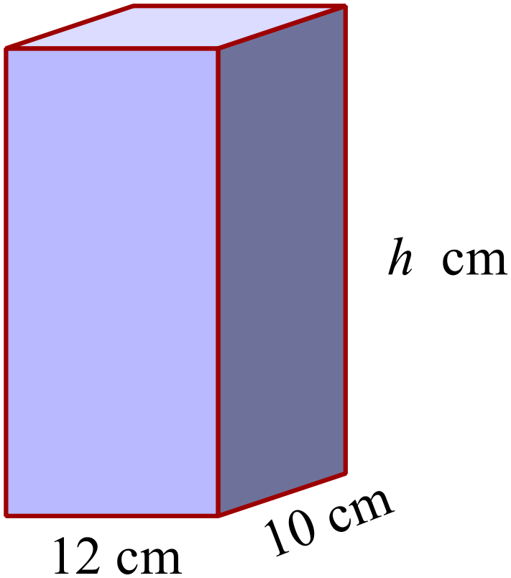What is its height (h cm)?

……………………………………………

…………………………………………....

…………………………………………….
What is the volume of a cube with sides 6 cm?

……………………………………………………………………………………………....

……………………………………………………………………………………………….
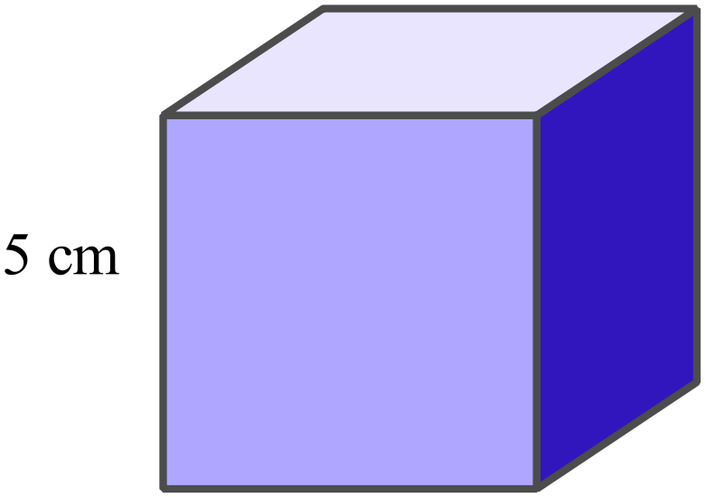What is the surface area of a cube with sides 5 cm?

……………………………………………

……………………………………………

……………………………………………
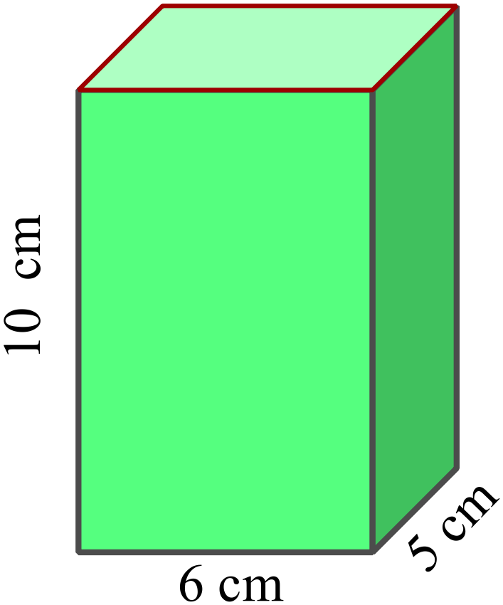What is the surface area of the rectangular prism?

……………………………………………

…………………………………………....

…………………………………………….
The solid is made by joining cubes together.
Each cube measures 2 cm on each edge.
What is the volume of the solid?
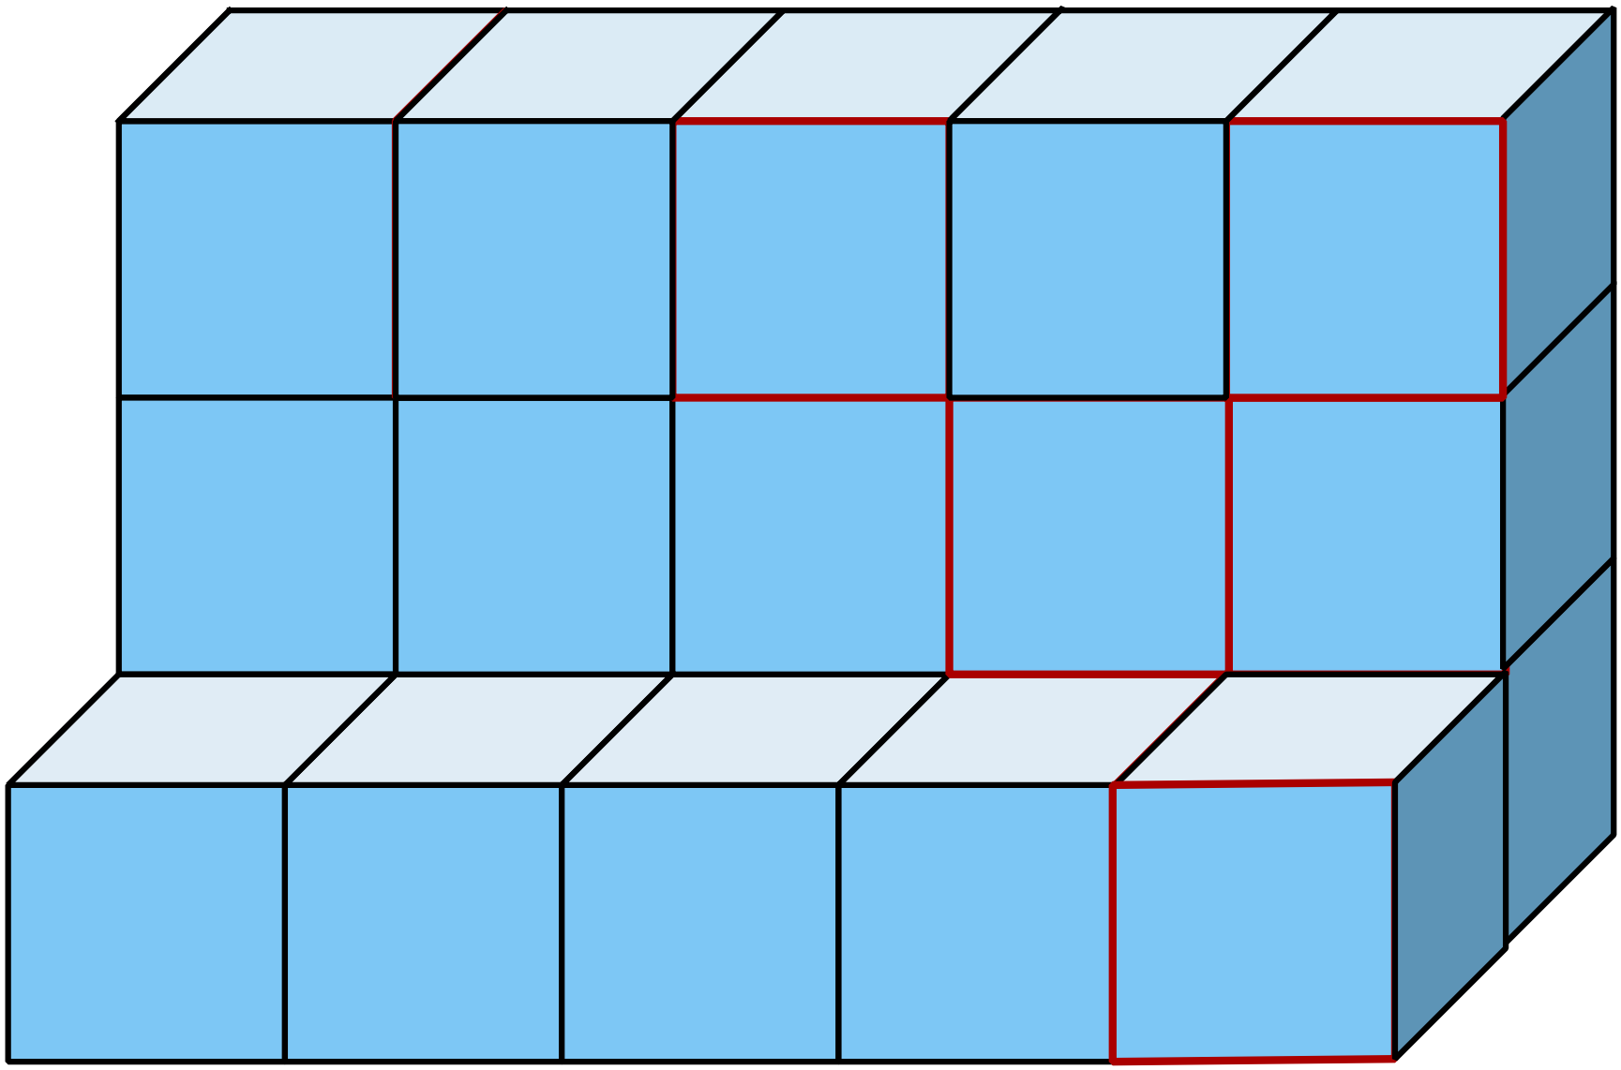

……………………………………………

…………………………………………....

…………………………………………….
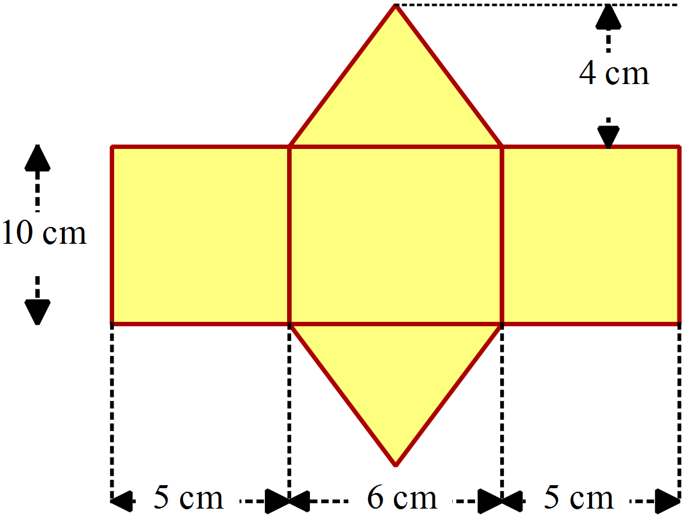Find the surface area of the solid whose net is shown.

………………………………………………

……………………………………………....

………………………………………………

……………………………………………….
The prism has a rhombus as its base.
What is its volume?
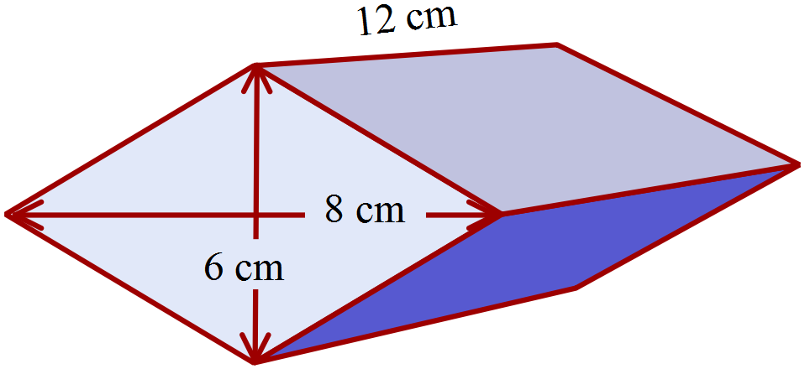

…………………………………………………

…………………………………………………

…….…………………………………………....

…………………………………………………
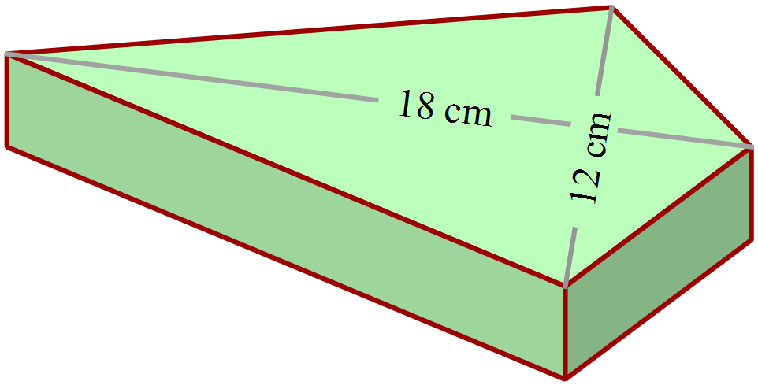A paperweight is a prism with a face in the shape of a kite, as shown.
It is 3 cm thick and made of glass.
What volume of glass is used to make the paperweight?

…………………………………………………

…………………………………………………

…….…………………………………………....

…………………………………………………
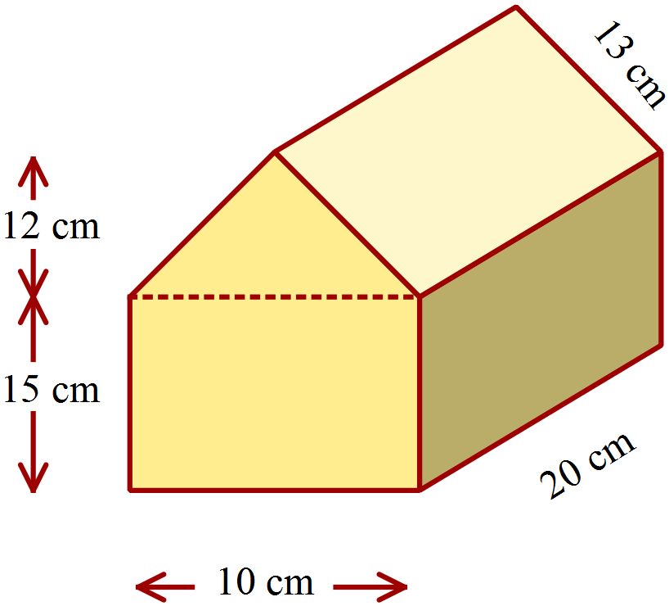Calculate the surface area of the prism shown.

…………………………………………………

…………………………………………………

…….…………………………………………....

…………………………………………………
The diagram shows a picnic hamper.
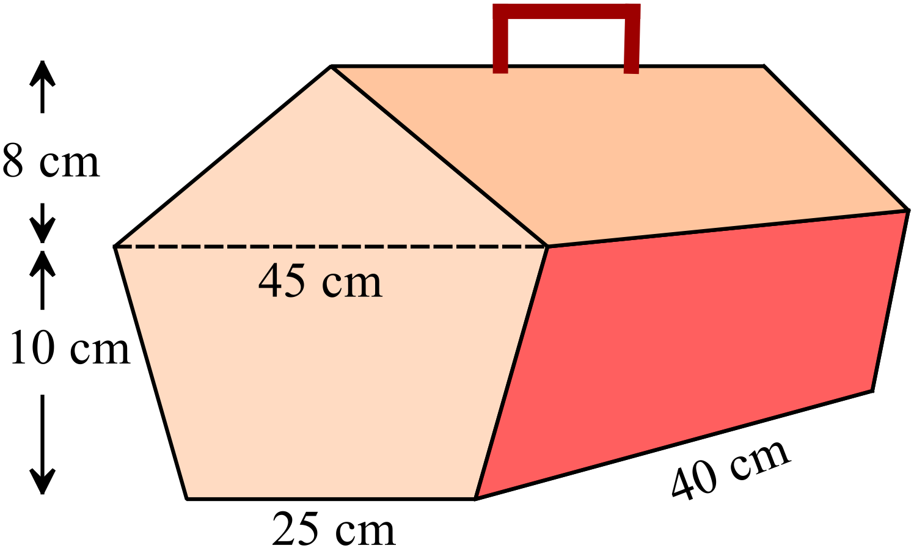Find the volume of the hamper?

…………………………………………

…………………………………………………

…….…………………………………………....

…………………………………………………

A storage hut is in the shape of a half cylinder.
The diameter of the semicircle is 10 metres and the length of the hut is 16 metres.
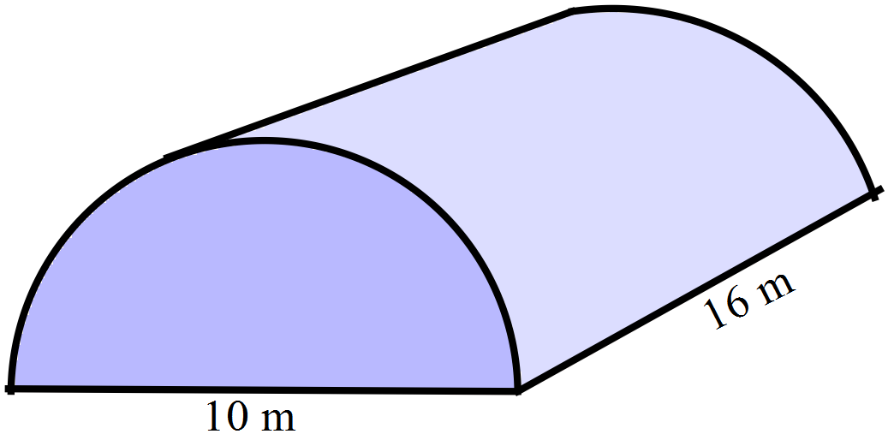What is its volume, answer in terms of 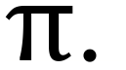

…………………………………………………

…………………………………………………

…….…………………………………………....

…………………………………………………
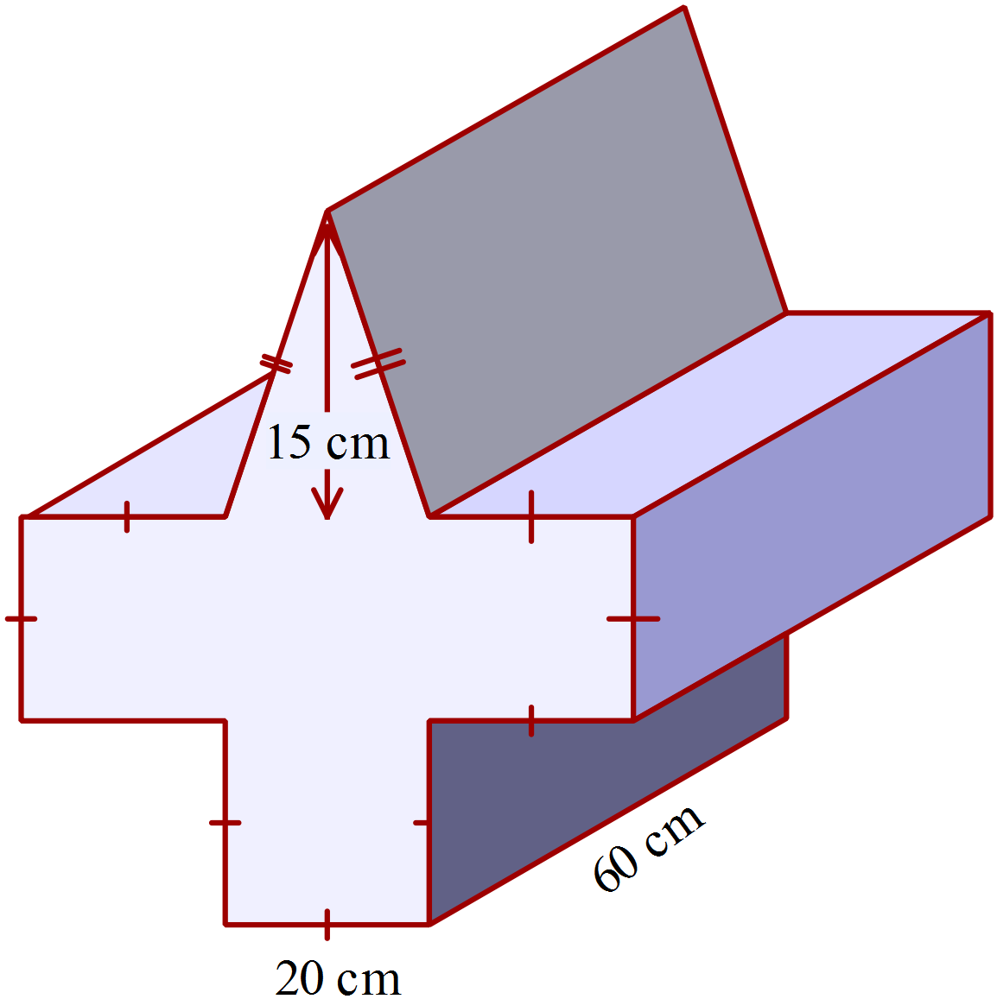Part of an artwork is a prism, in the shape shown.

Calculate the volume of the prism.

…………………………………………………

…………………………………………………

…………………………………………………

…………………………………………………

…….…………………………………………....

…………………………………………………
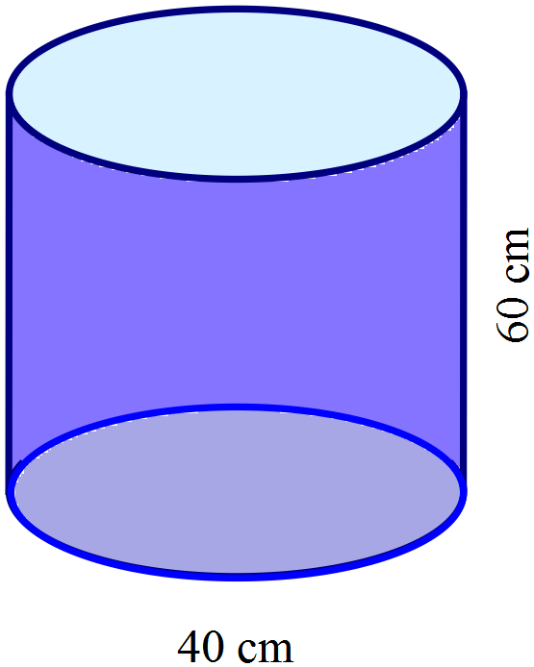A cylindrical water cooler is 60 cm high and has a diameter of 40 cm.
The cylindrical cups that are provided with the cooler have a radius of 2 cm and a height of 10 cm.
How many cups could be filled from the cooler?

…………………………………………………

…………………………………………………

…….…………………………………………....

…………………………………………………
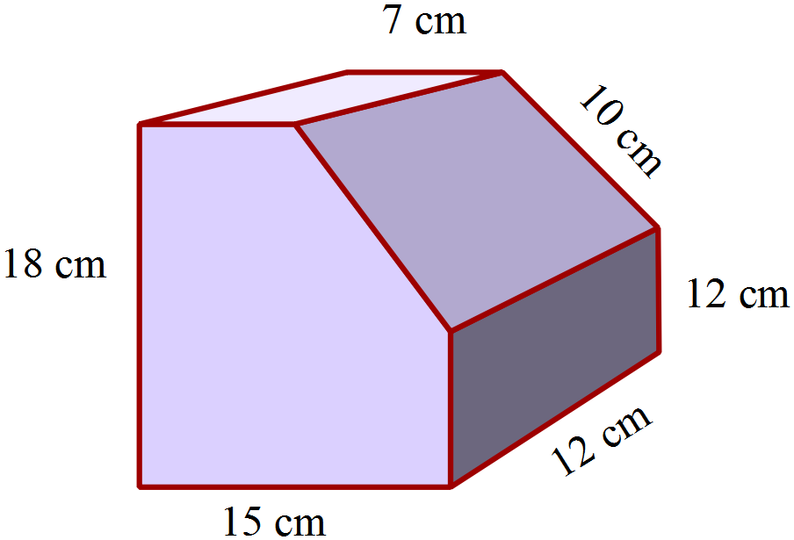Calculate the surface area of the prism shown.

…………………………………………………

…………………………………………………

…….…………………………………………....

…………………………………………………

Year 9 |  | Volume and SA of Prisms and Cylinders | Calculator Allowed
 |  | Volume and SA of Prisms and Cylinders | Name_________________
Section 2 Multiple Choice Section
Mark all your answers on the accompanying multiple choice answer sheet, not on this test paper. You may do any working out on this test paper. Calculators are allowed for this section.

 | 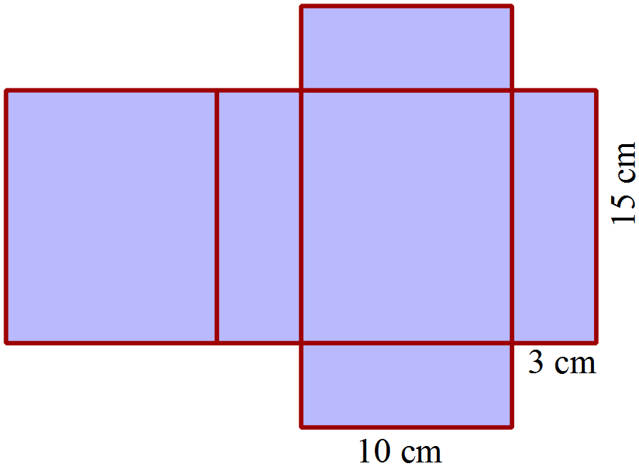 Questions 1 – 3 refer to the net shown.
What solid would be formed from the net?

A. Rectangular prism
B. Rectangular pyramid.
C. Square prism.
D. Square pyramid.
What is the total area of the net?

A. 225 cm² B. 300 cm² C. 405 cm² D. 450 cm²
What is the volume of the solid formed from the net?

A. 225 cm³ B. 300 cm³ C. 405 cm³ D. 450 cm³
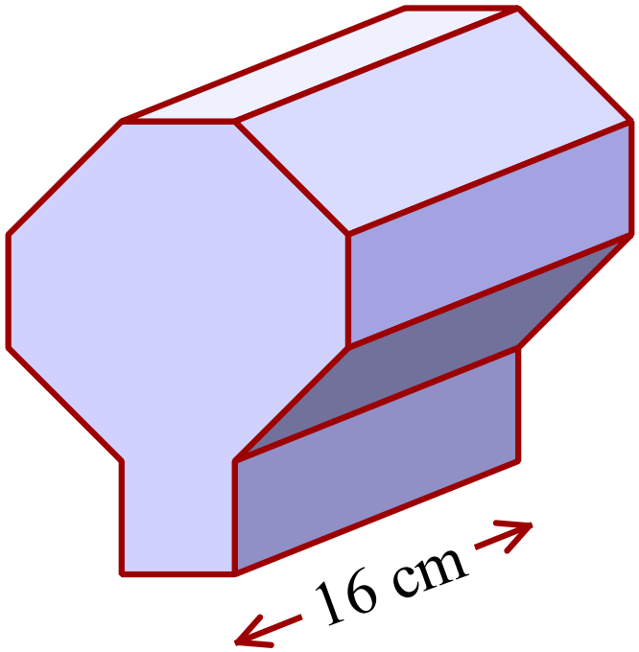The area of the cross section of this prism is 250 cm².
What is the volume of the prism?

A. 2 000 cm³
B. 3 200 cm³
C. 4 000 cm³
D. 8 000 cm³
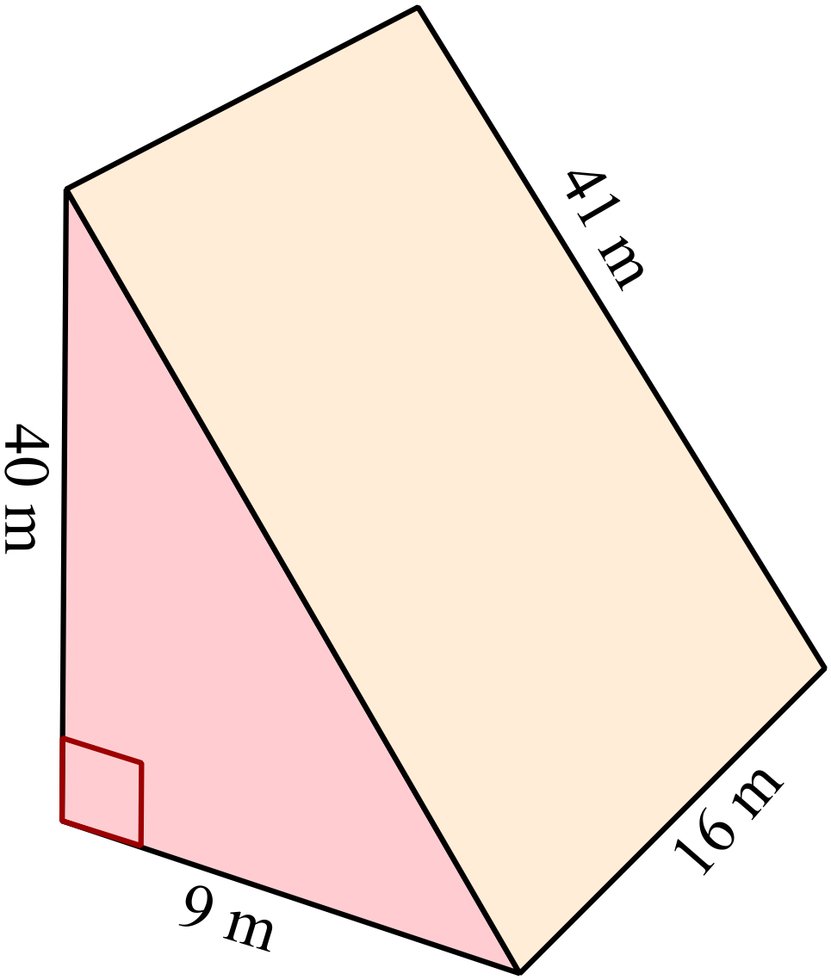Which calculation could be used to find the volume of the triangular prism shown?

A. 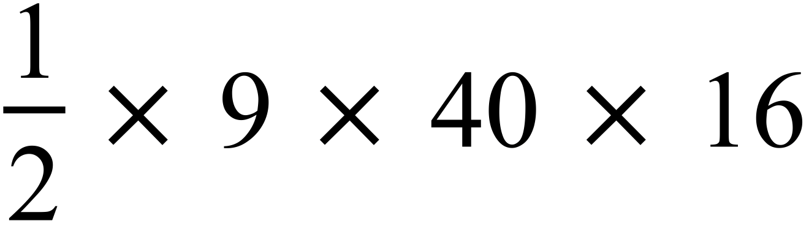

B. 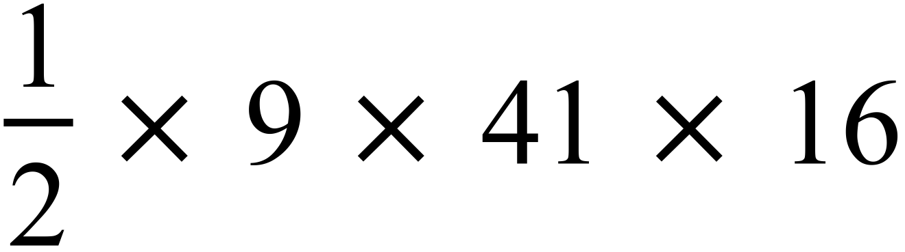

C. 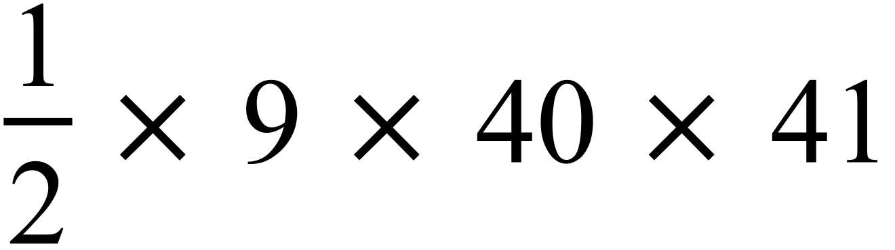

D. 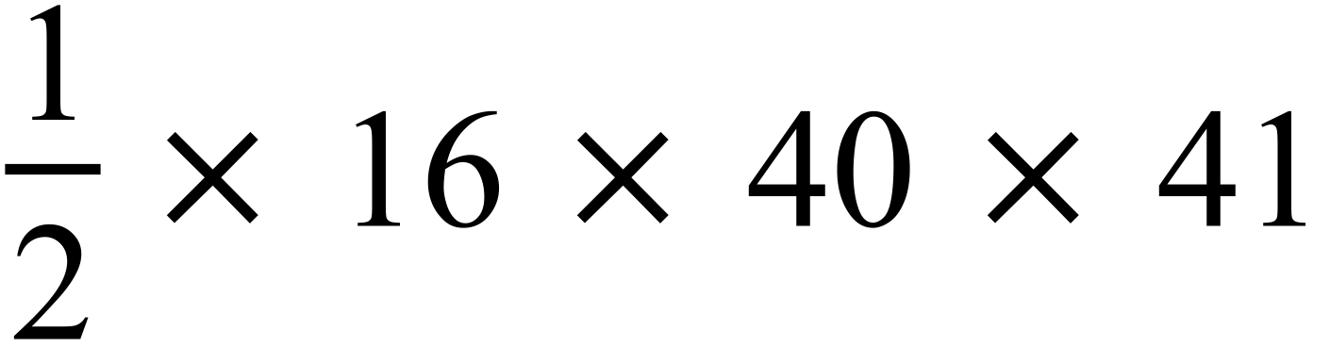

How many cubic centimetres are there in a cubic metre?
A. 100
B. 10 000
C. 1 000 000
D. 100 000 000
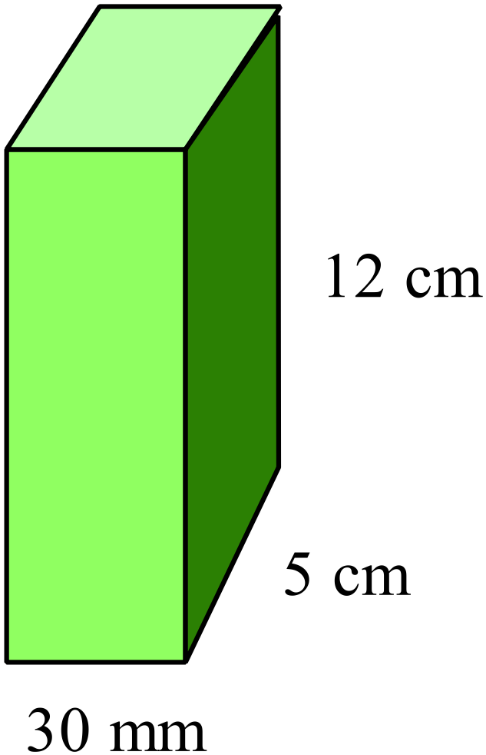What is the volume of the prism shown?

A. 18 cm³
B. 180 cm³
C. 1 800 cm³
D. 18 000 cm³

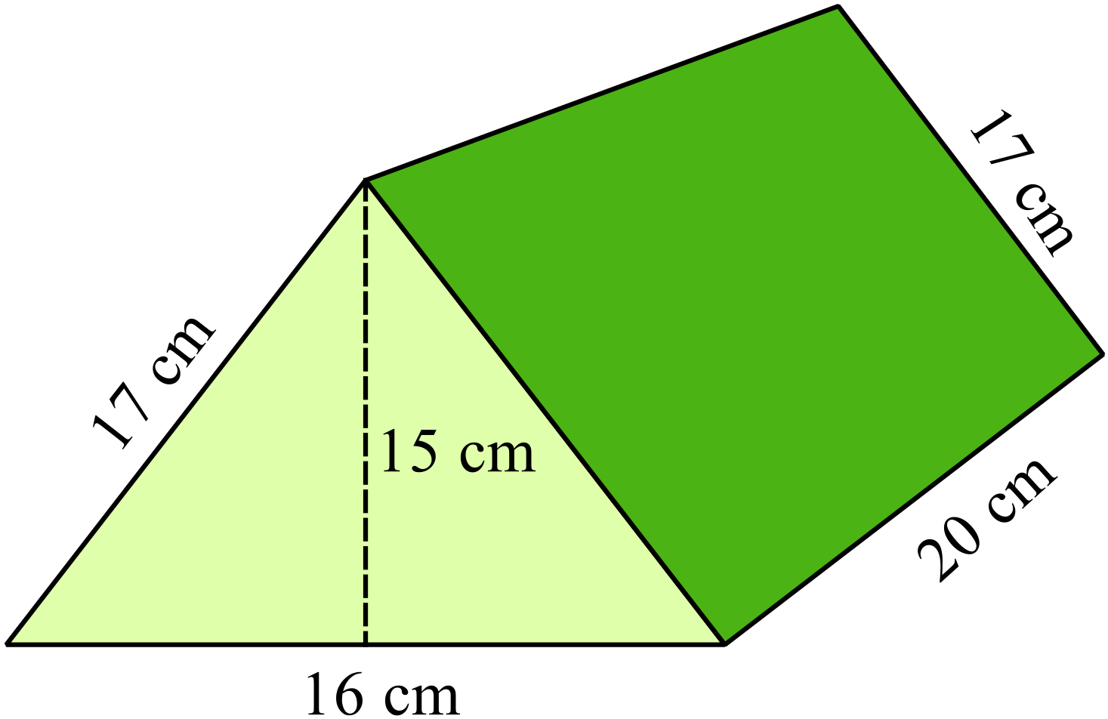What is the surface area of the triangular prism shown?

A. 900 cm²
B. 1 000 cm²
C. 1 240 cm²
D. 1 560 cm²

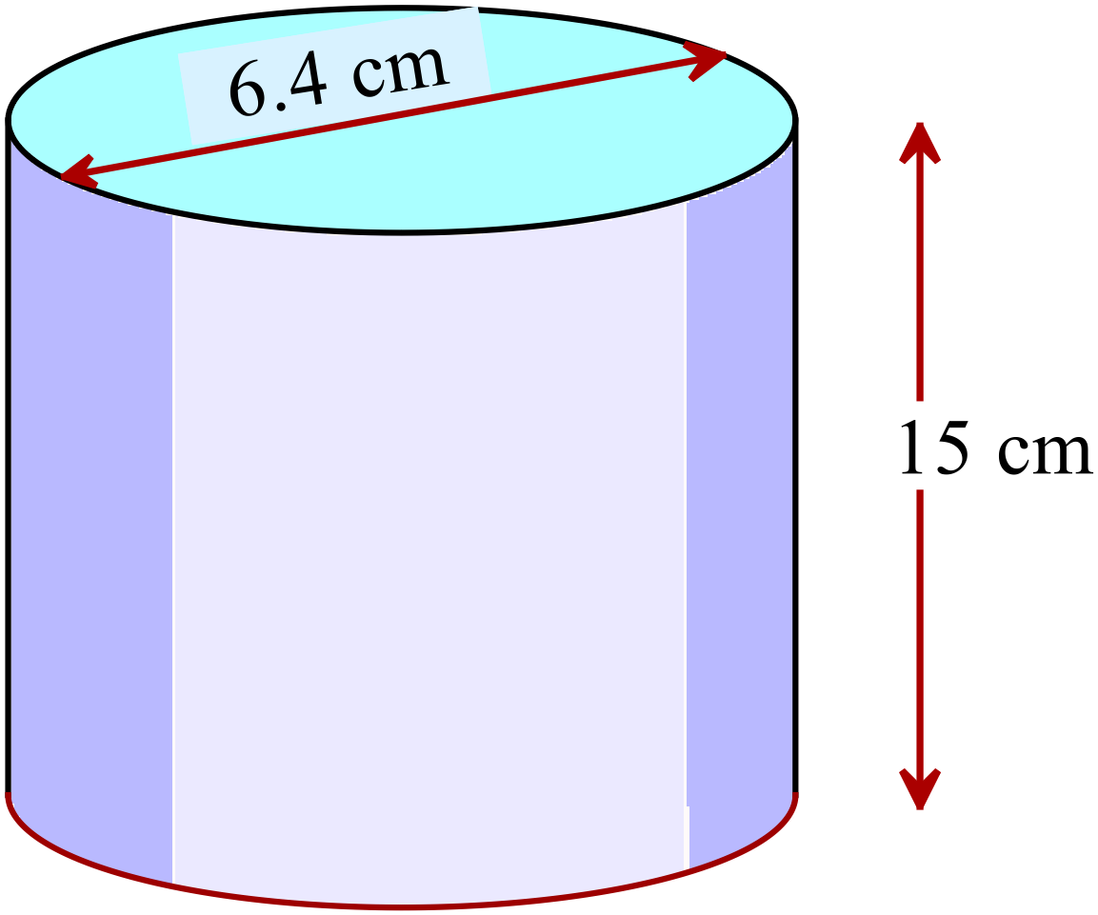What is the volume of the cylinder to the nearest cm³?

A. 151 cm³
B. 483 cm³
C. 603 cm³
D. 1 930 cm³

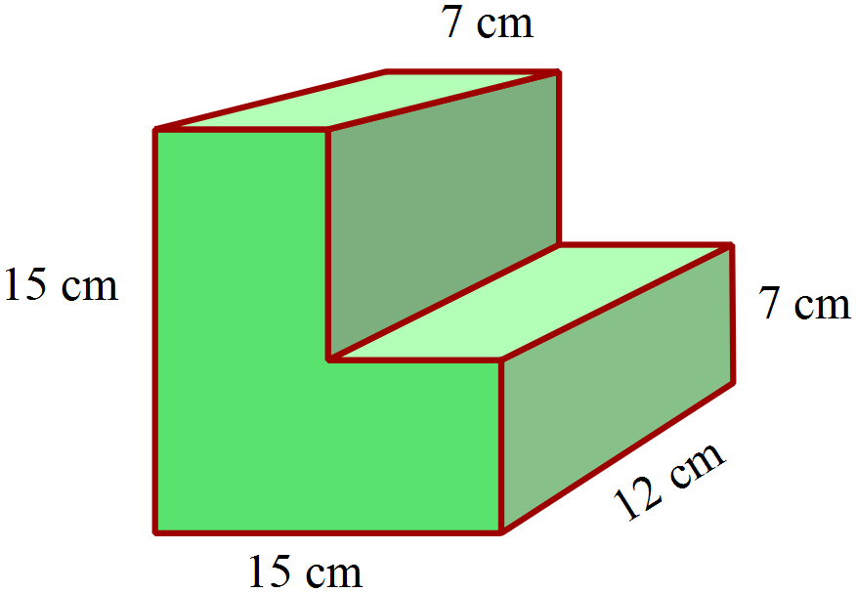What is the volume of the solid shown?

A. 161 cm³
B. 966 cm³
C. 1 932 cm³
D. 2 112 cm³

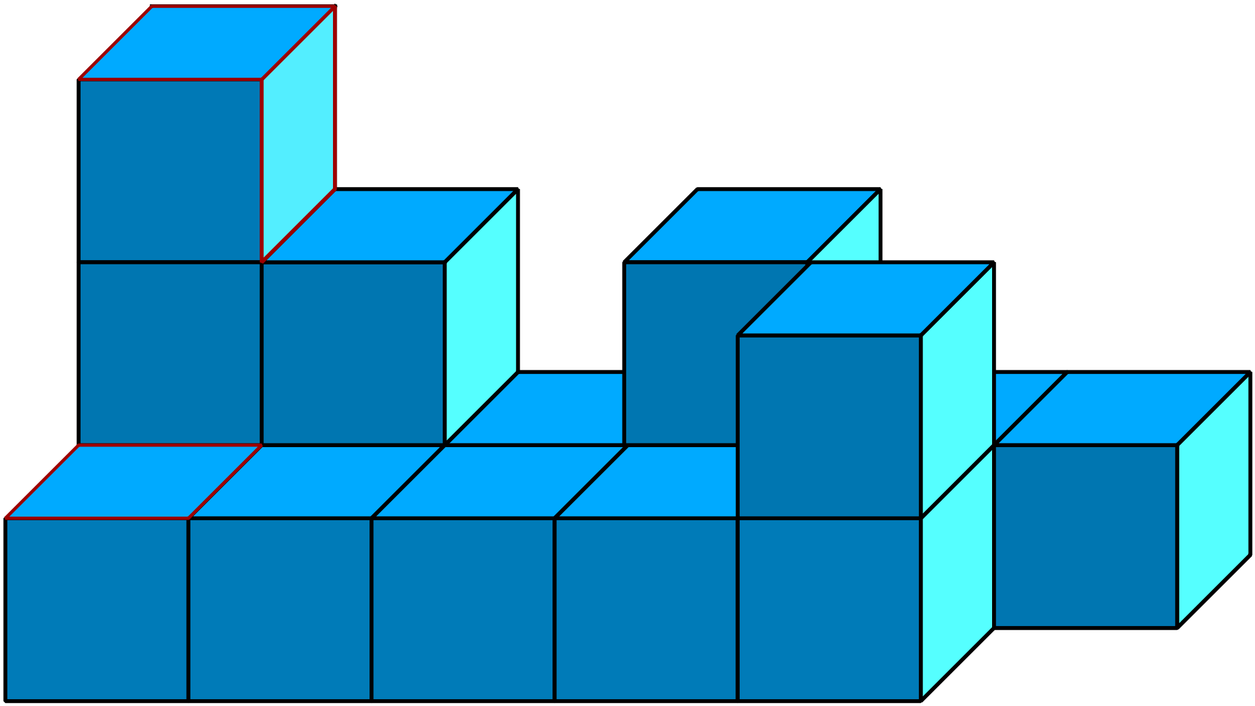Jack is building a prism from 1 cm² cubes. What is the least number of cubes he must add to produce a prism?
A. 6
B. 8
C. 12
D. 14

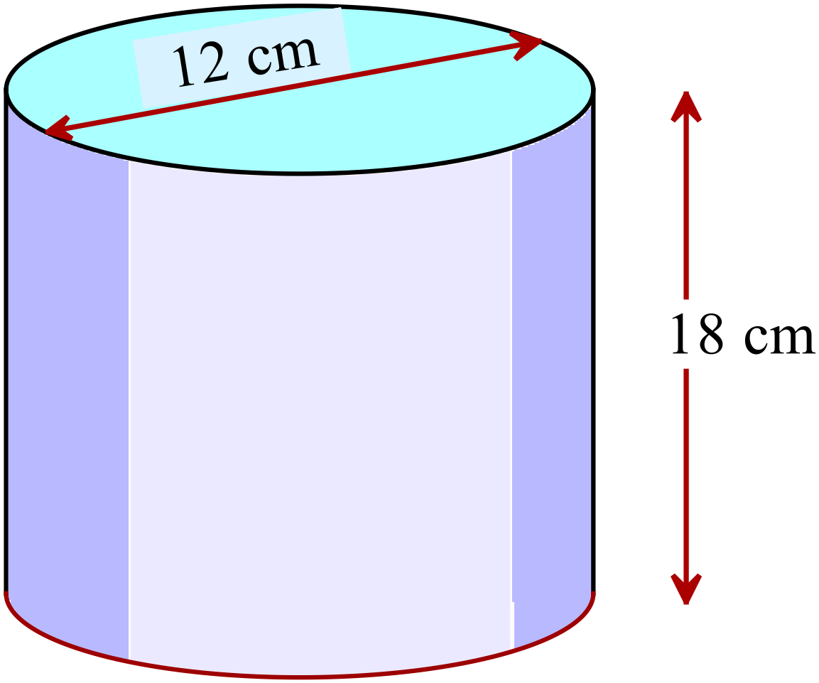What is the surface area of the cylinder?
Answer to the nearest cm².

A. 905 cm²
B. 1 131 cm²
C. 1 507 cm²
D. 1 583 cm²

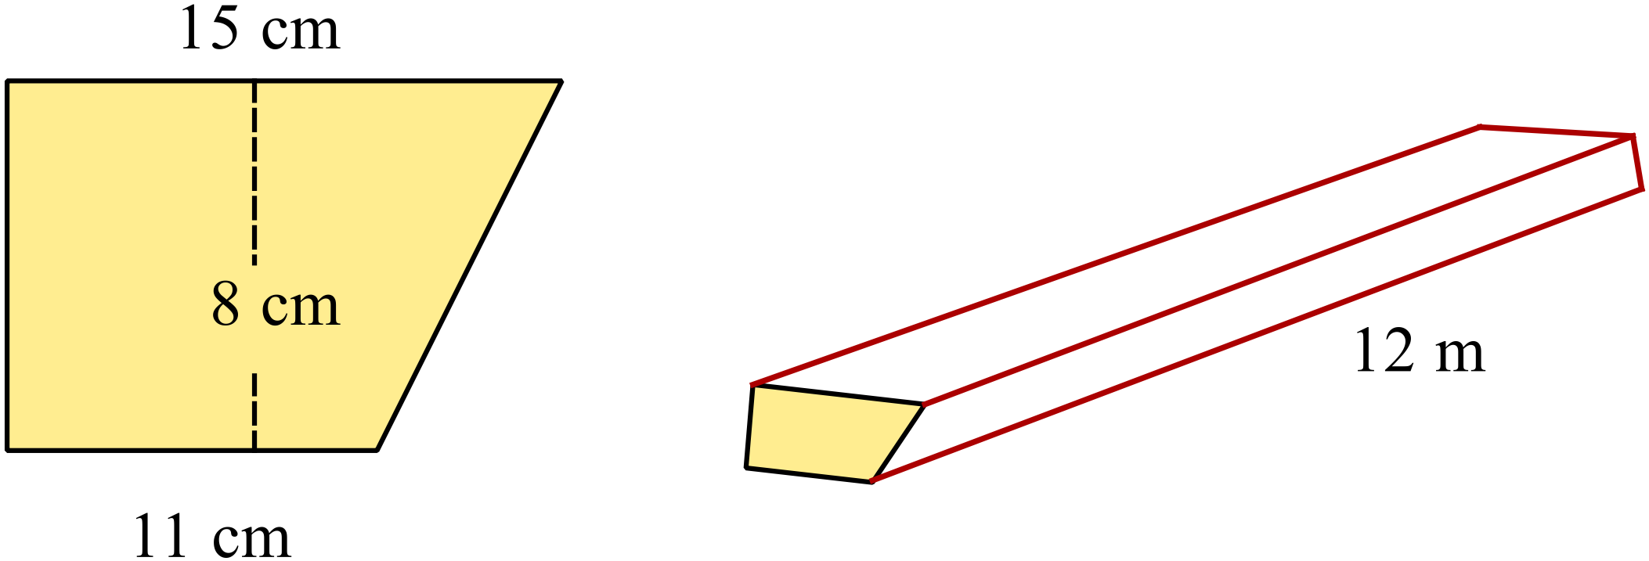A section of guttering is in the shape of the trapezoidal prism, with cross section as shown.
Its length is 12 metres.
How many litres of water could the section hold when it was completely full?
(1 000 cm³ holds 1 litre)

A. 12.5 litres B. 25.6 litres C. 62.4 litres D. 124.8 litres

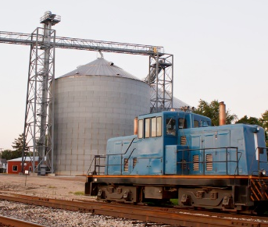
A cylindrical grain silo has an internal diameter of 12 metres and a height of 45 metres.
If each cubic metre of grain weighs 0.75 tonnes, how many rail wagons which carry 120 tonnes each would be needed to empty the silo when it is full?

A. 16 B. 32 C. 35 D. 43
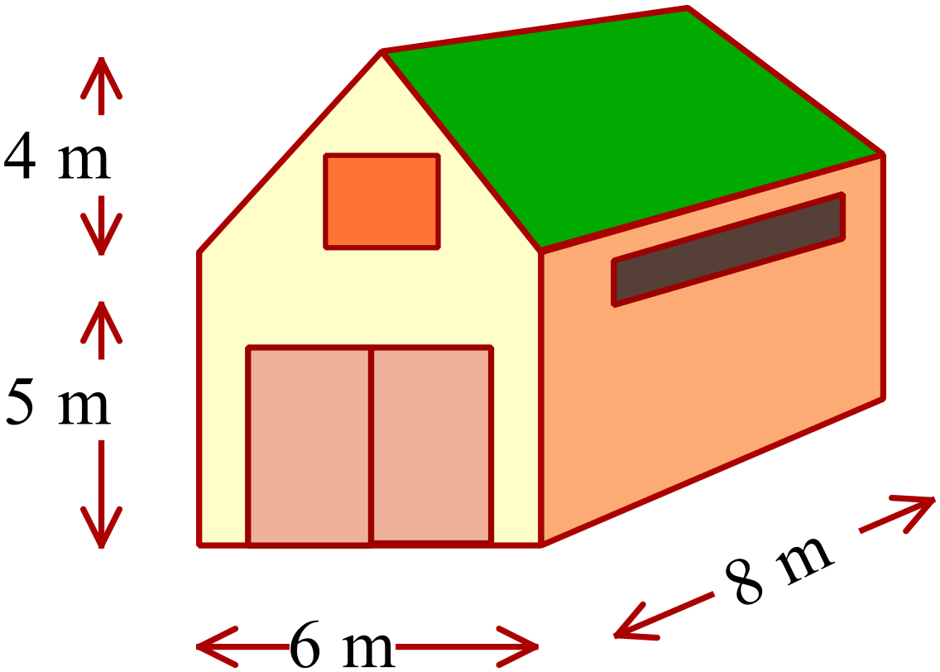A barn has the dimensions shown.
Calculate the volume of the barn in cubic metres.

A. 108 m³
B. 216 m³
C. 256 m³
D. 336 m³

Multiple Choice Answer Sheet
Volume and SA of Prisms and Cylinders
Name _____________________________________________
Completely fill the response oval representing the most correct answer.

1. A B C D
2. A B C D
3. A B C D
4. A B C D
5. A B C D
6. A B C D
7. A B C D
8. A B C D
9. A B C D
10. A B C D
11. A B C D
12. A B C D
13. A B C D
14. A B C D
15. A B C D
Year 9 |  | Volume and SA of Prisms and Cylinders | Non Calculator
Section 1 Short Answer Section
ANSWERS
No. | WORKING |  | ANSWER
 | 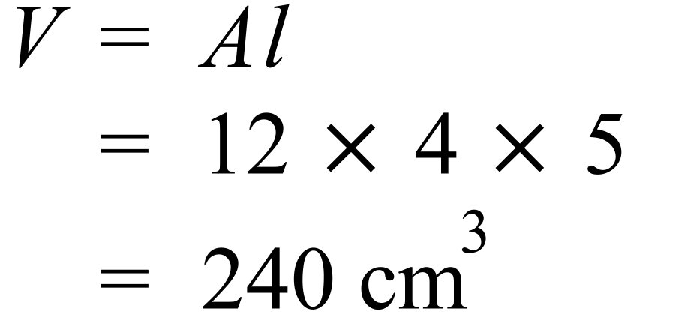 |  | 240 cm³
 | 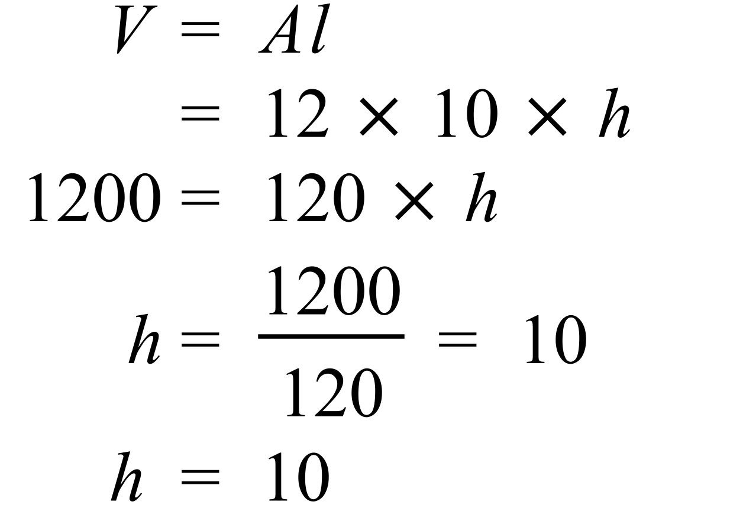 |  | 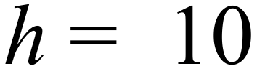
 | 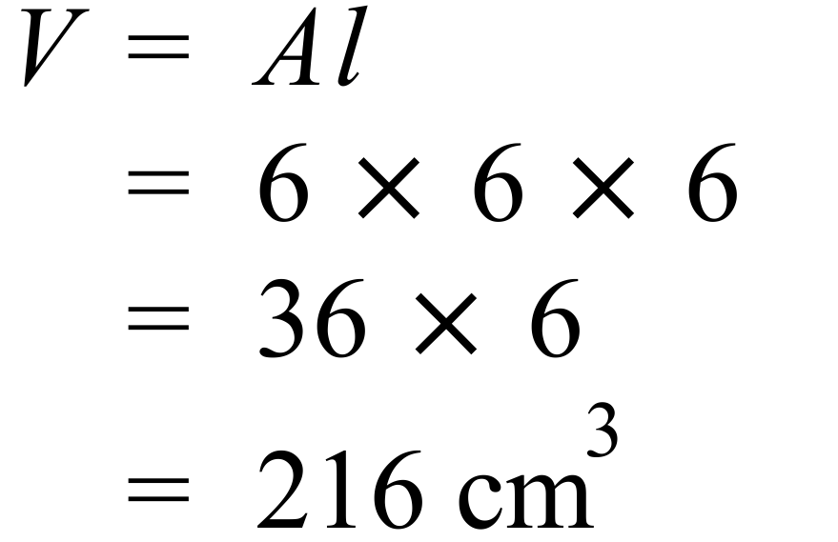 |  | 216 cm³
 | 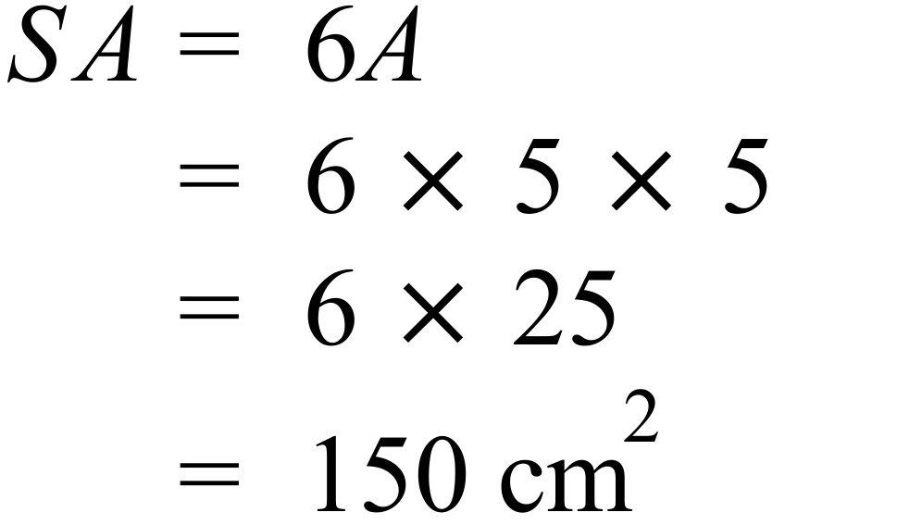 |  | 150 cm²
 | 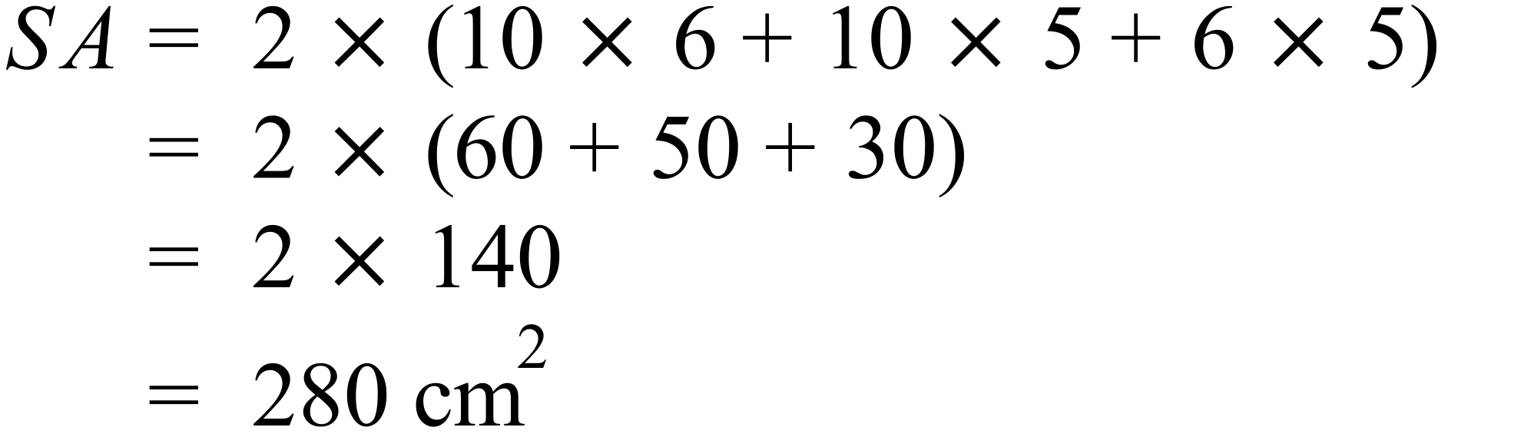 |  | 280 cm²
 | 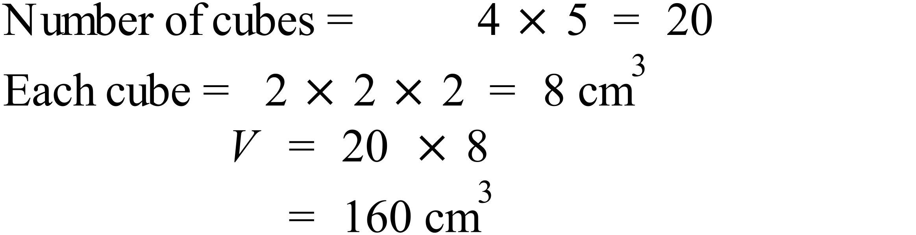 |  | 160 cm³
 | 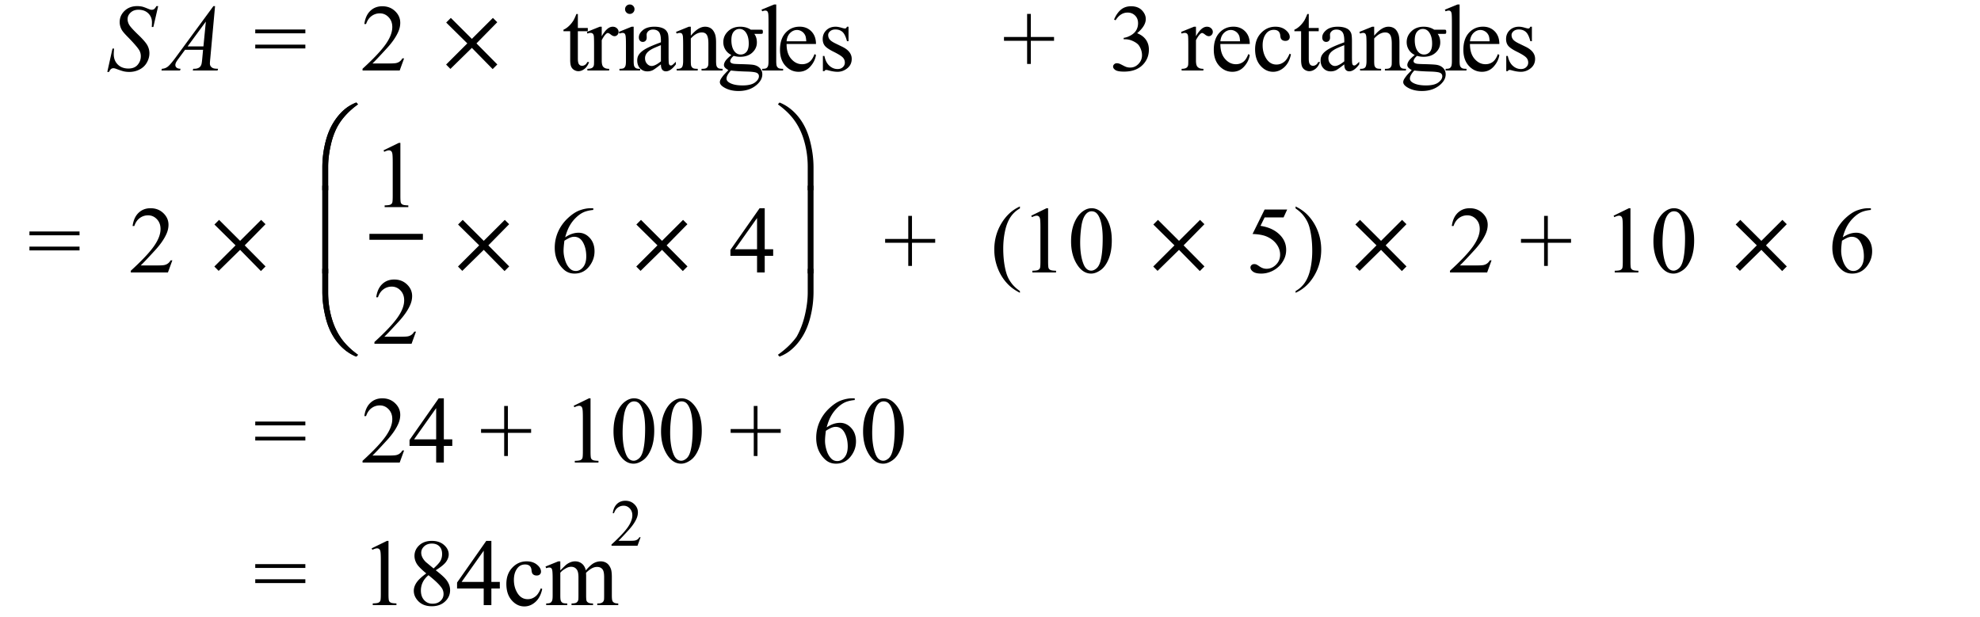 |  | 184 cm²
 | 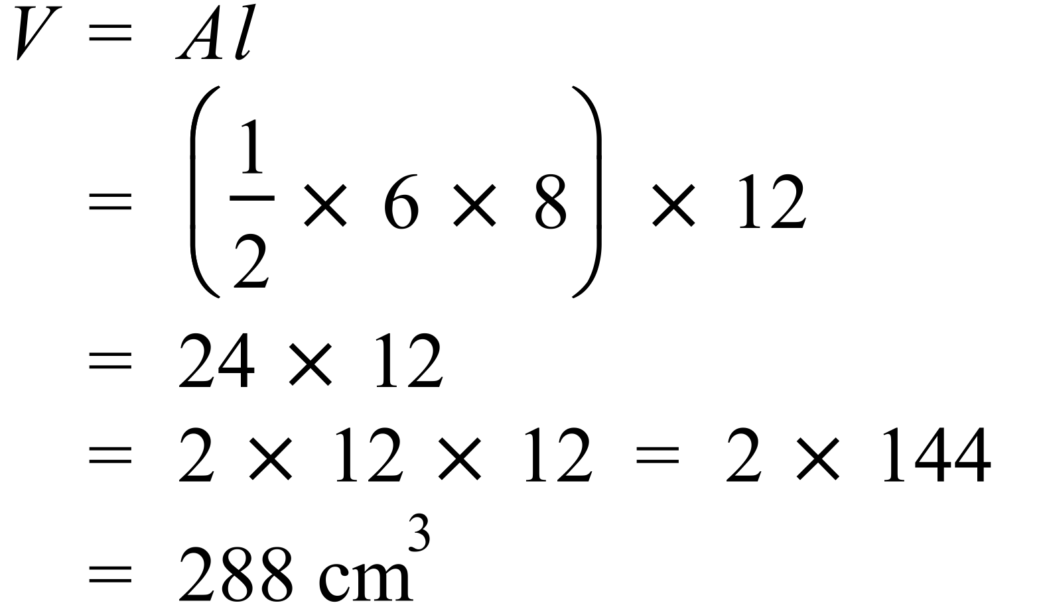 |  | 288 cm³
 | 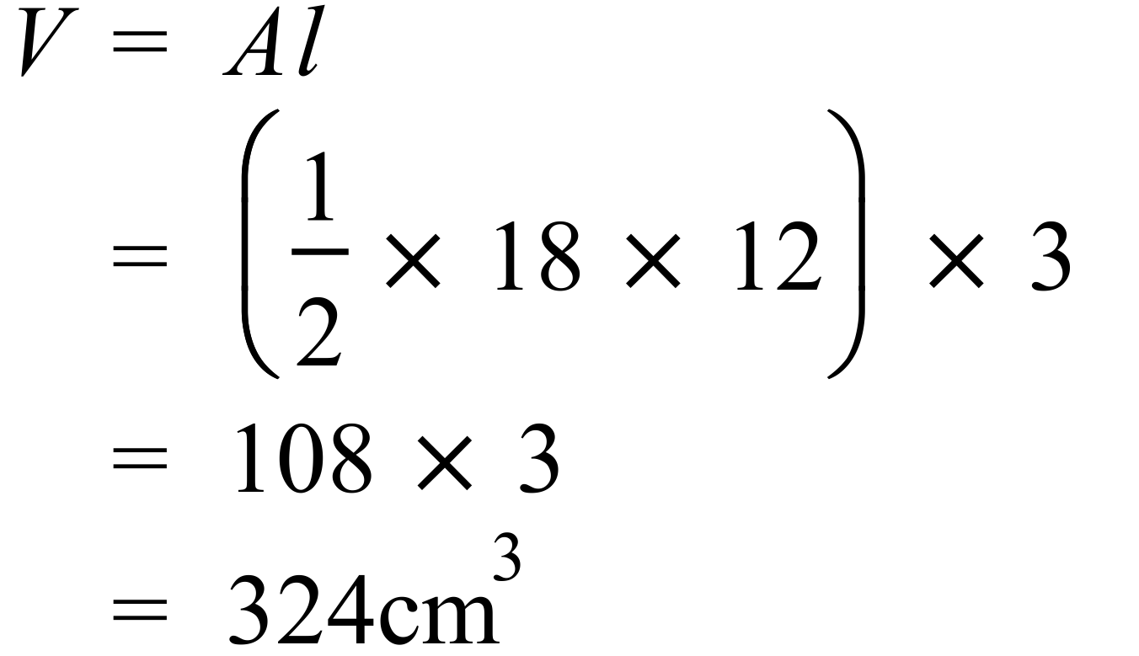 |  | 324 cm³
 | 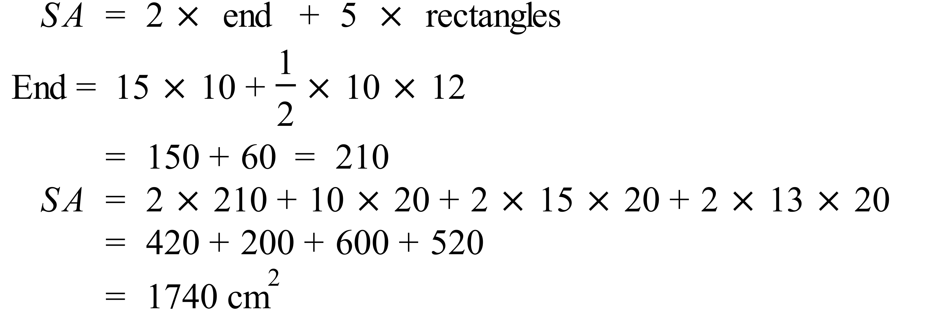 |  | 1740 cm²
 | 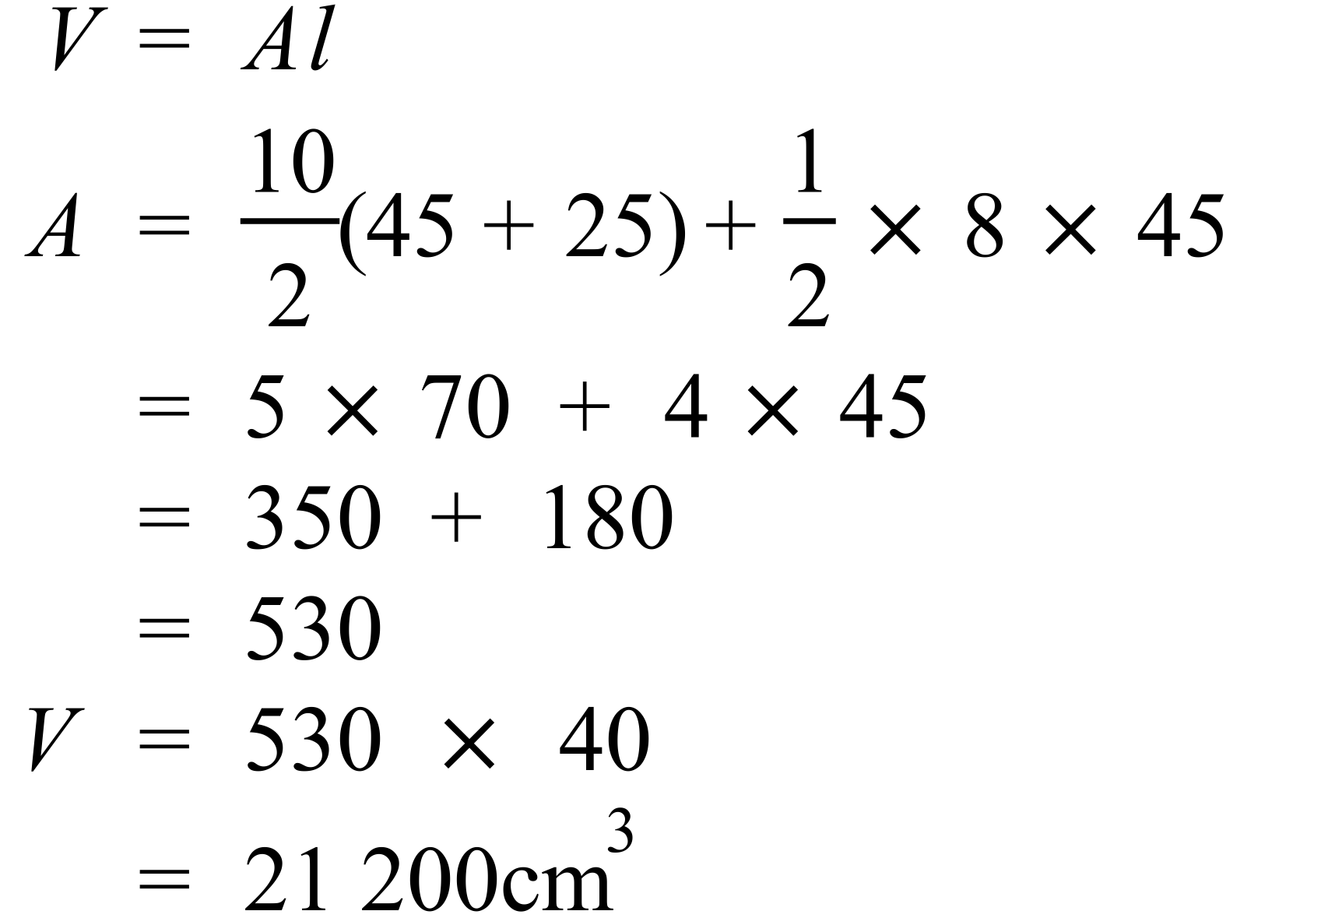 |  | 21 200 cm³
 | 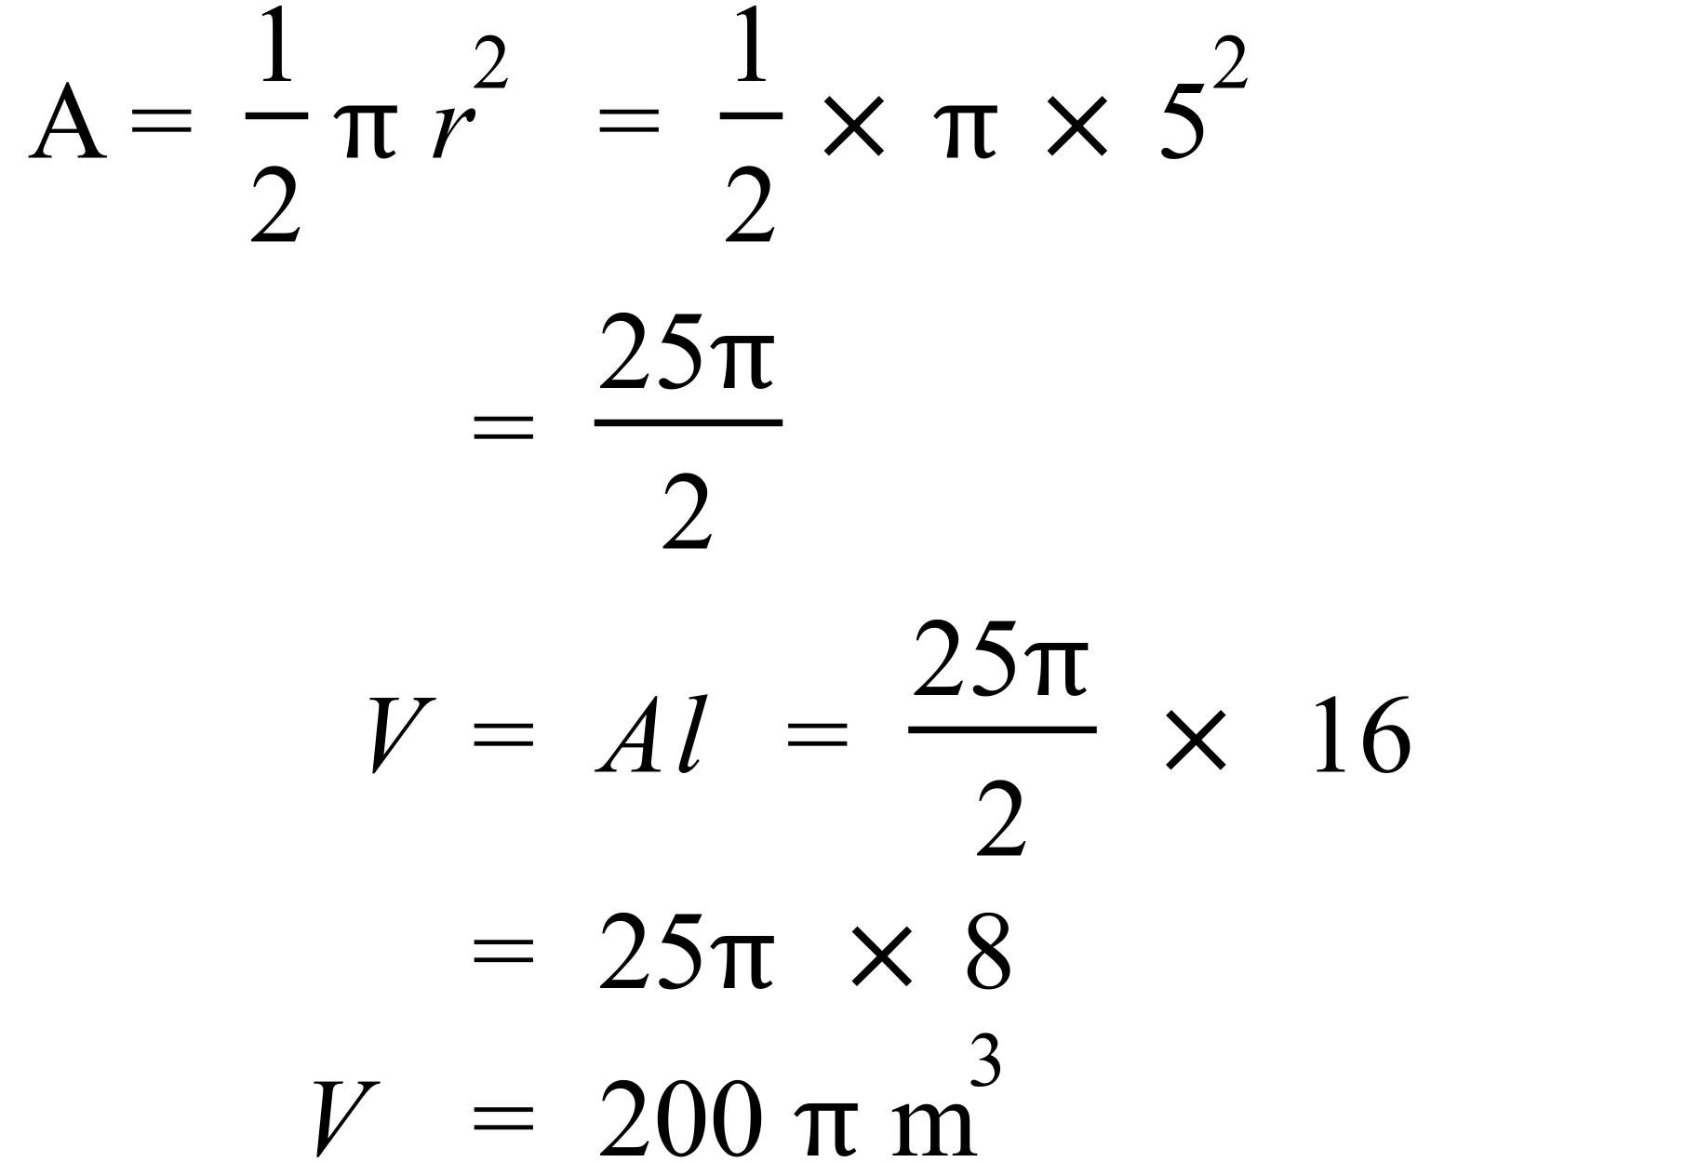 |  | 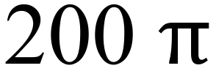 m³
 | 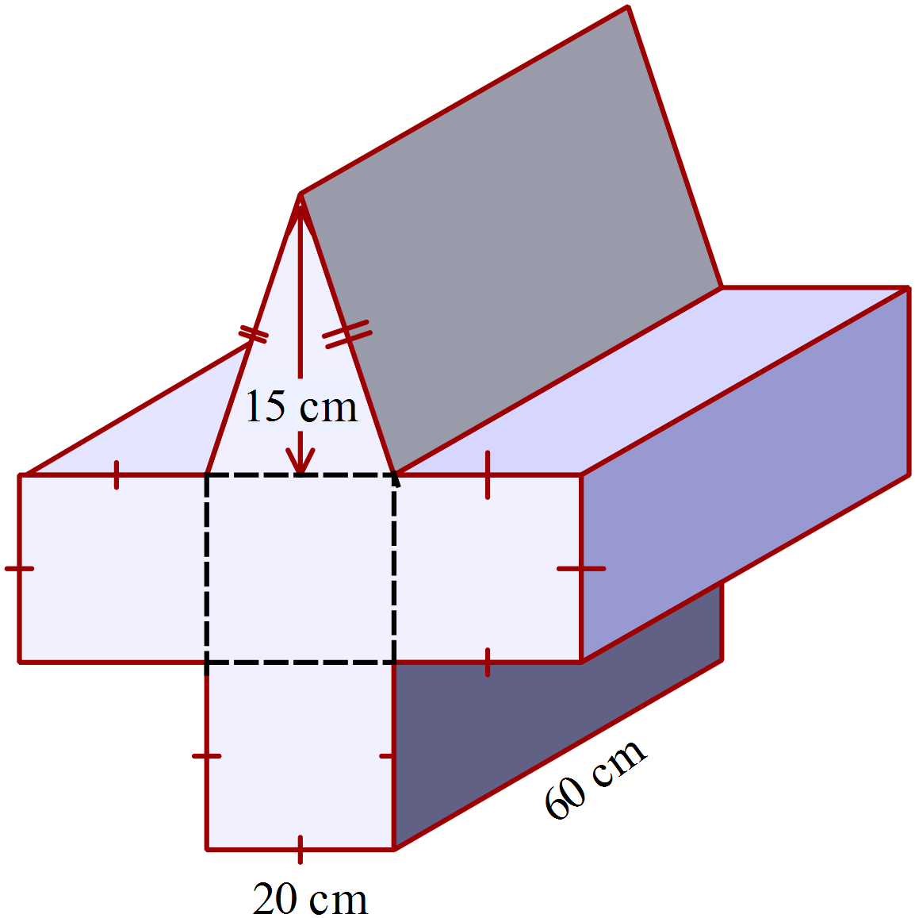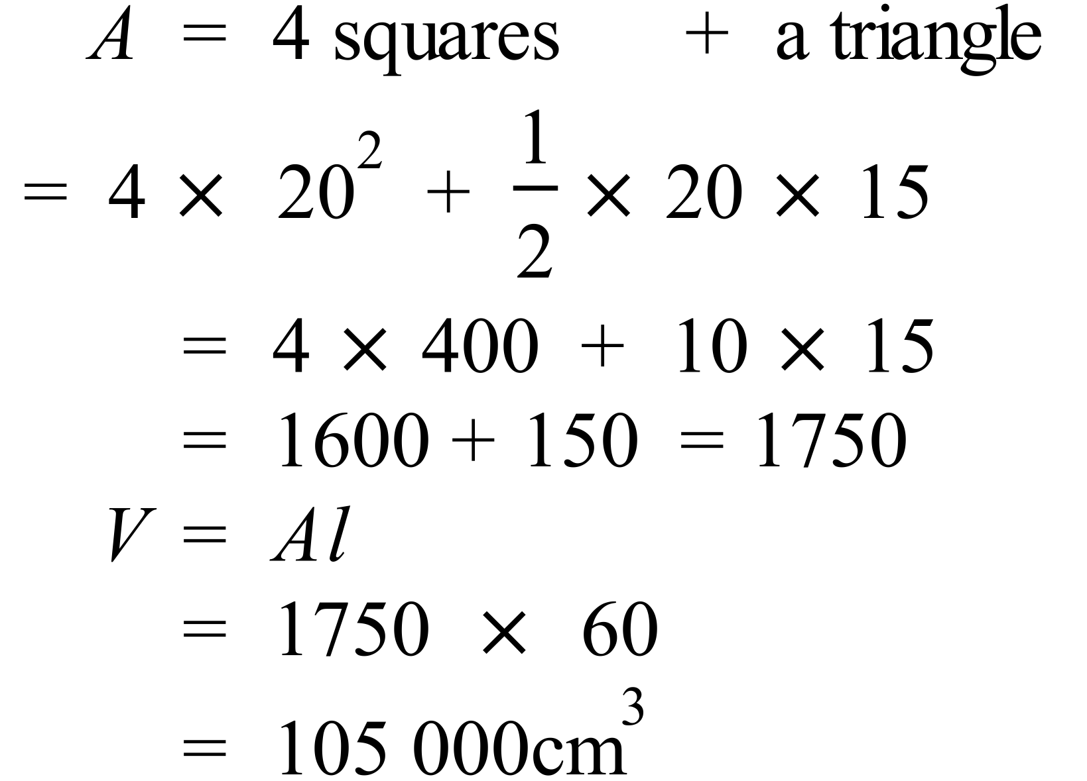 |  | 105 000 cm³
 | 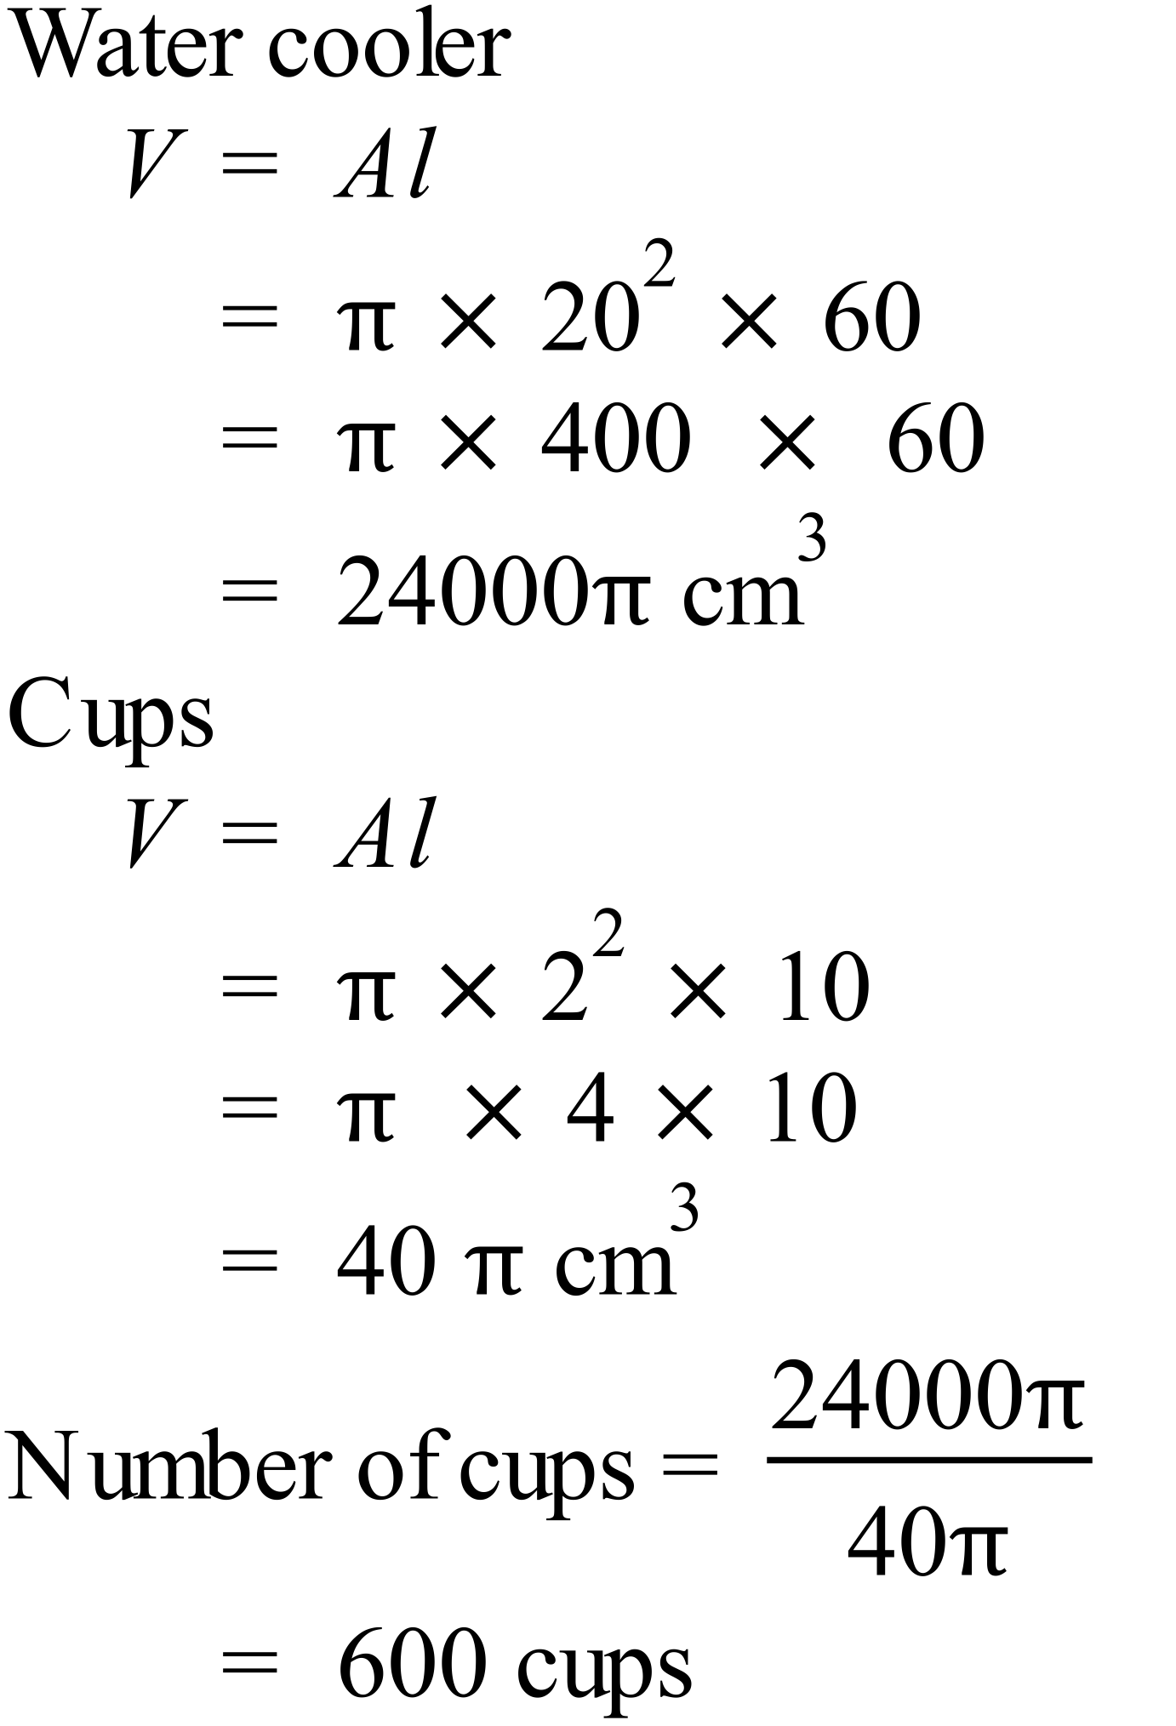 |  | 600 cups
 | 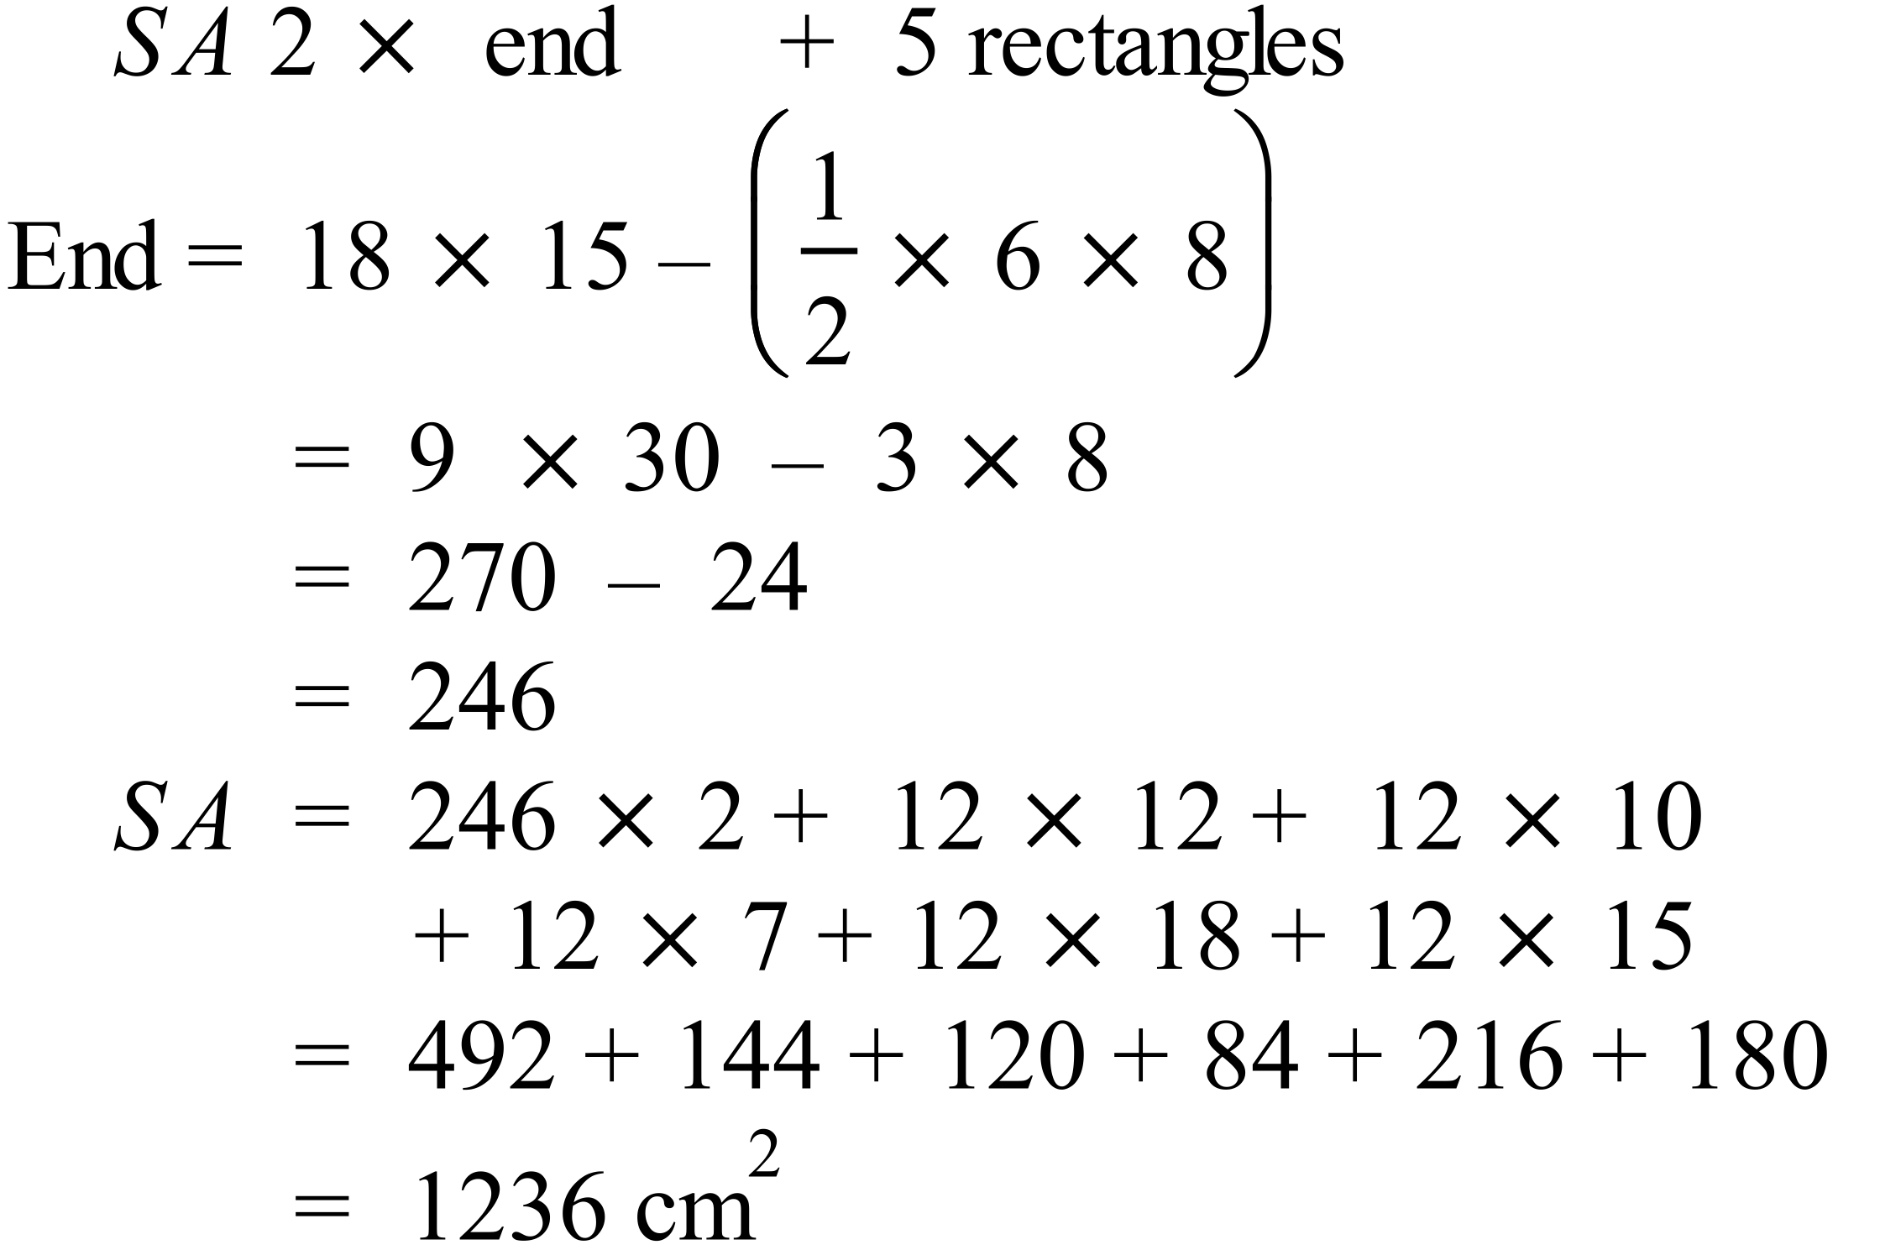 |  | 1 236 cm³

Year 9 |  | Volume and SA of Prisms and Cylinders | Calculator Allowed
Section 2 Multiple Choice Section
ANSWERS
No. | WORKING |  |  | ANSWER
 | It is a rectangular prism |  |  | A
 | 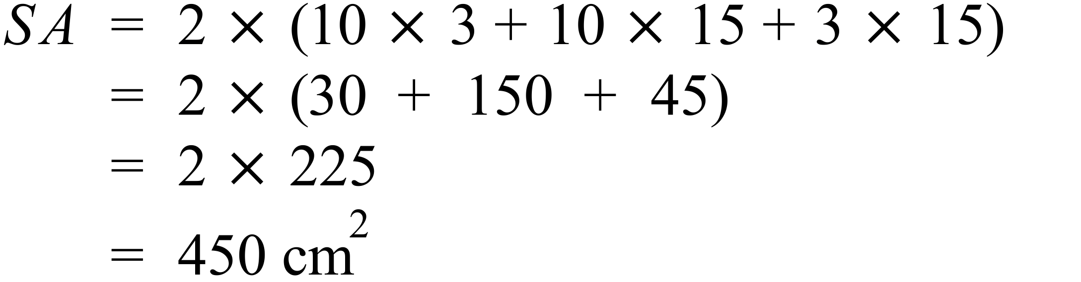 |  |  | D
 | 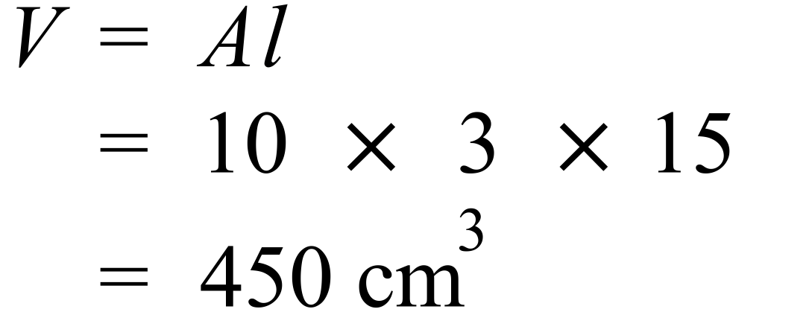 |  |  | D
 | 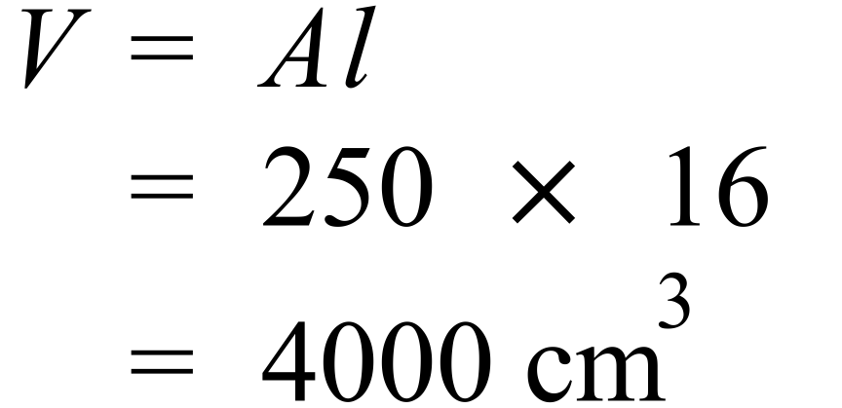 |  |  | C
 | 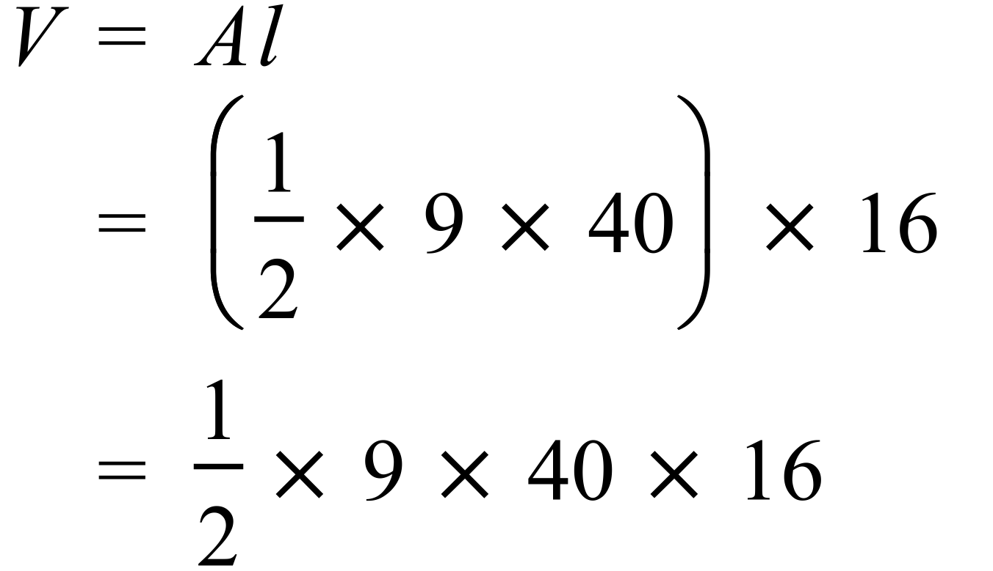 |  |  | A
 | 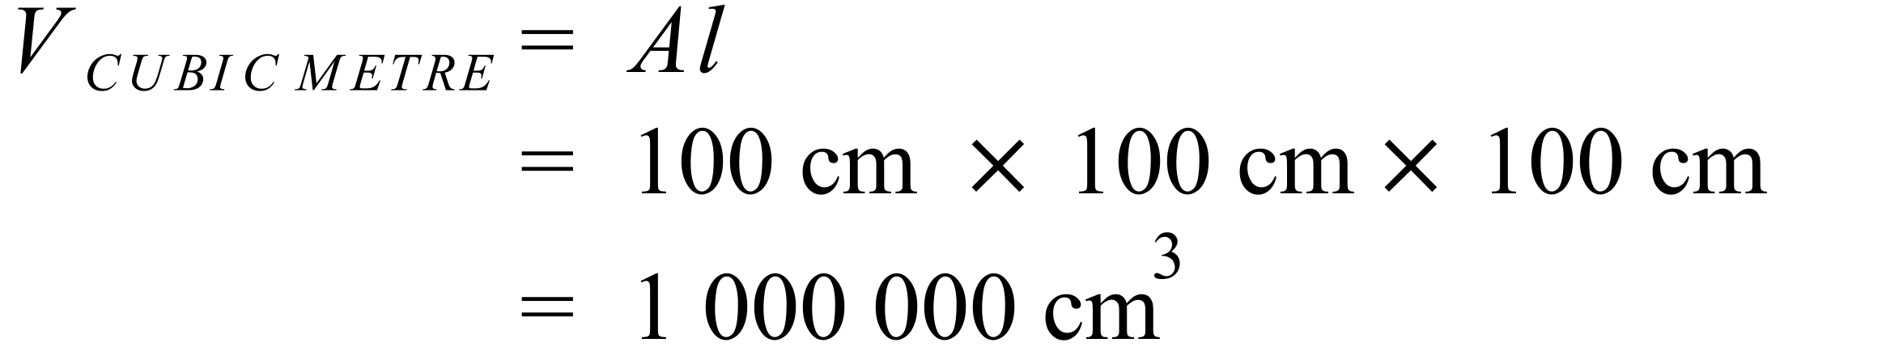 |  |  | C
 | 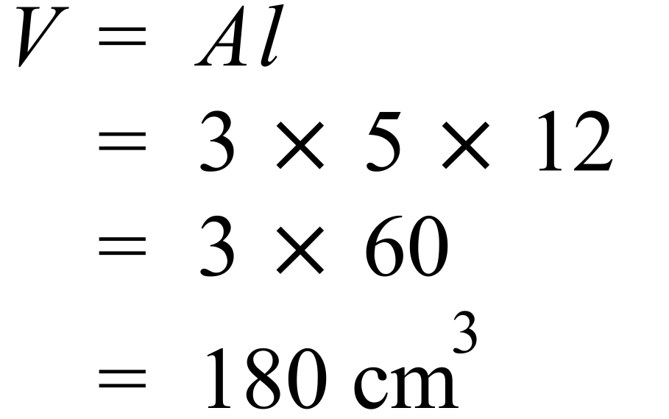 |  |  | B
 | 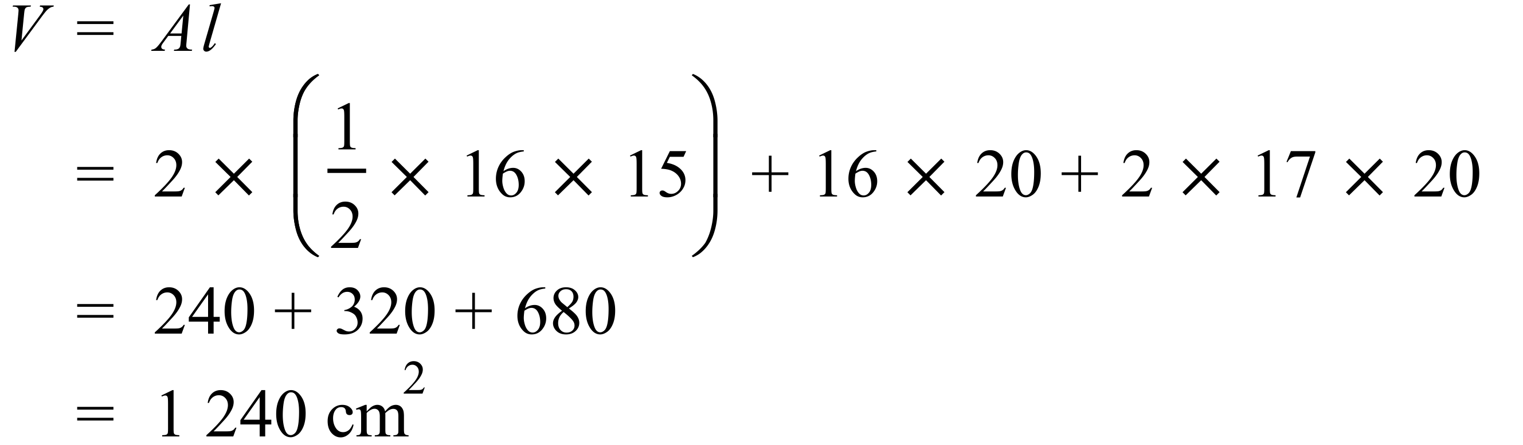 |  |  | C
 | 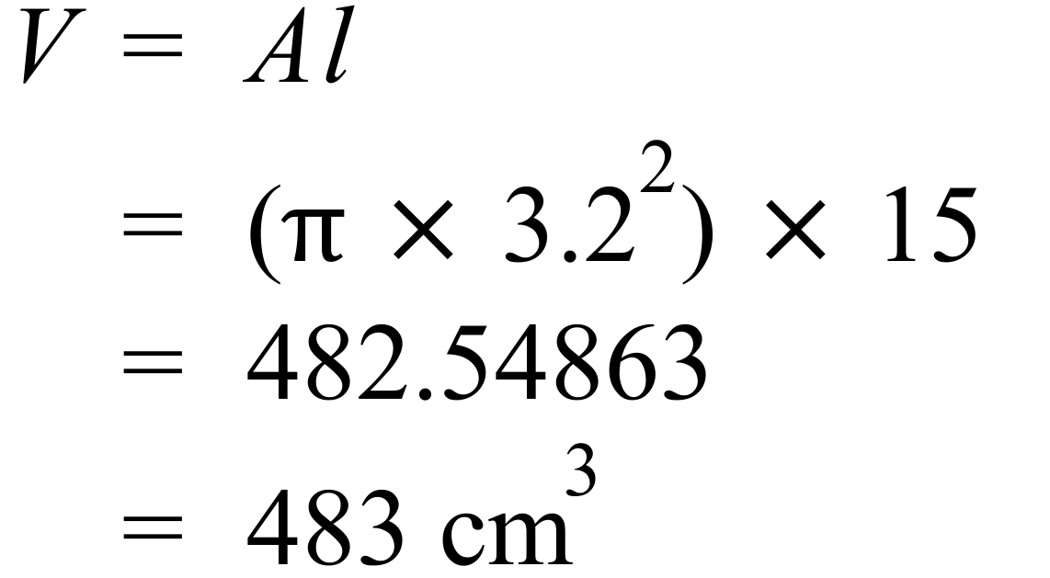 |  |  | B
 | 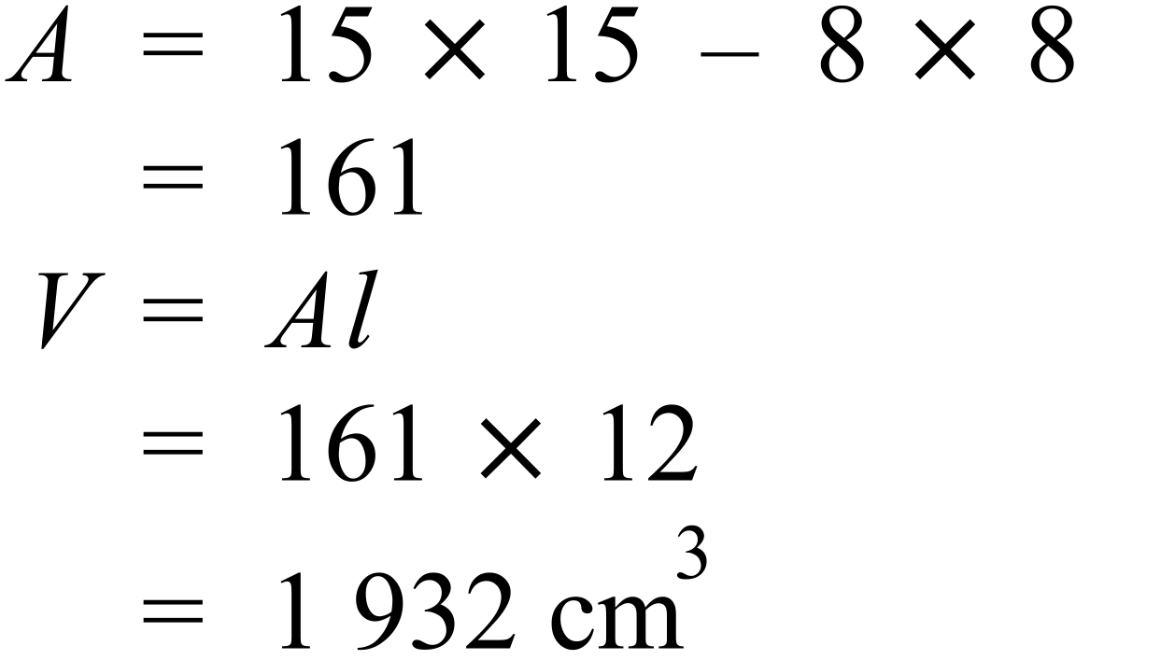 |  |  | C
 | 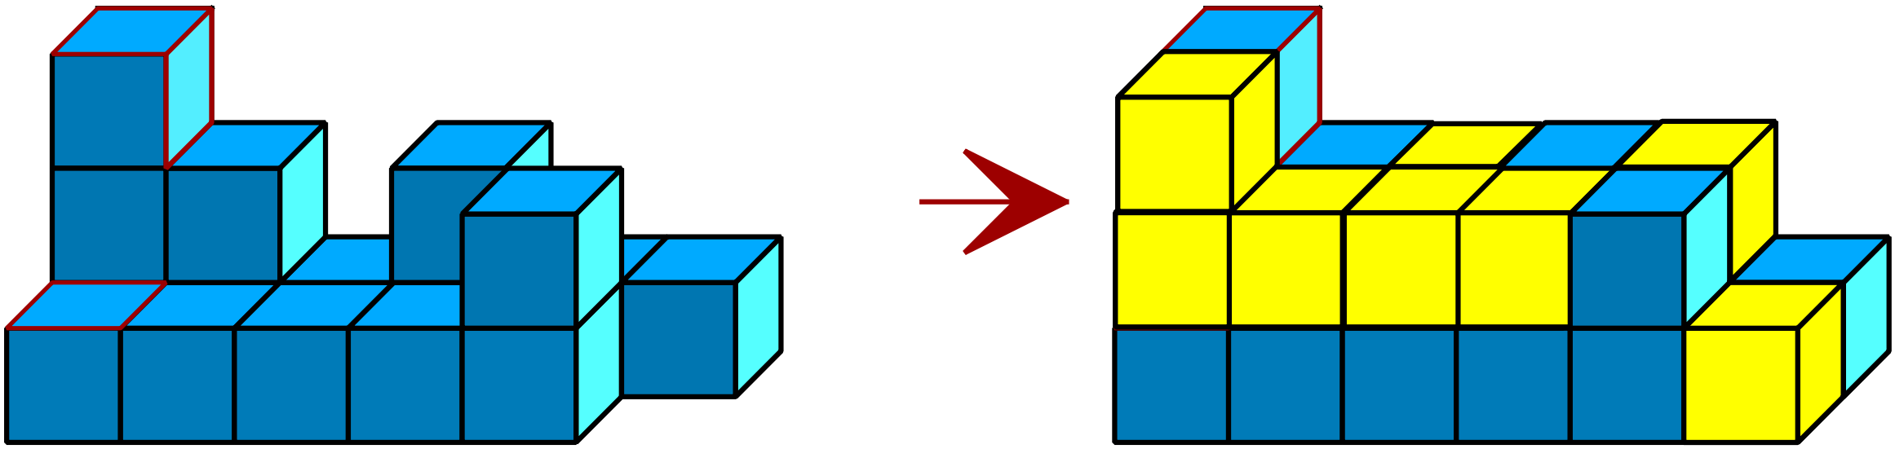  There are 8 added. |  |  | B
 | 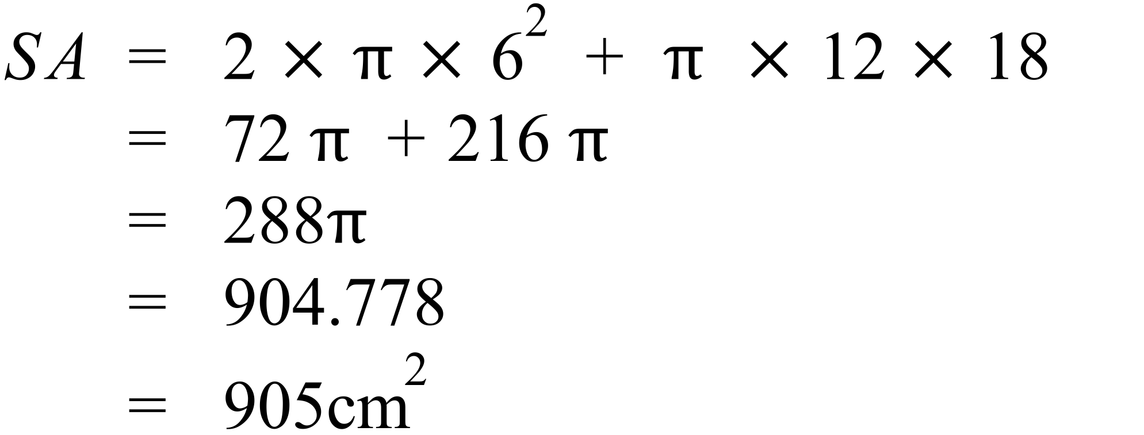 |  |  | A
 | 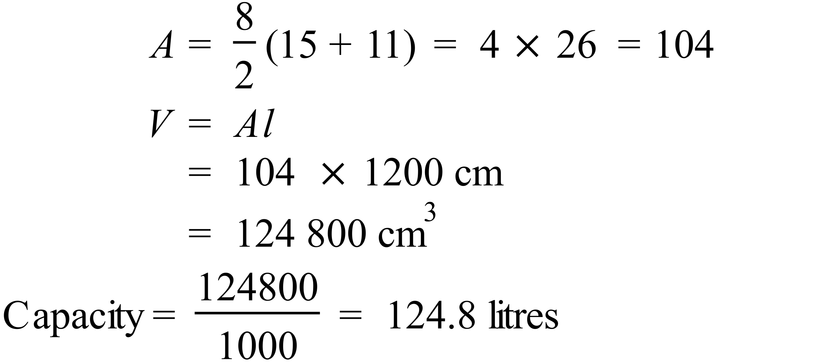 |  |  | D
 | 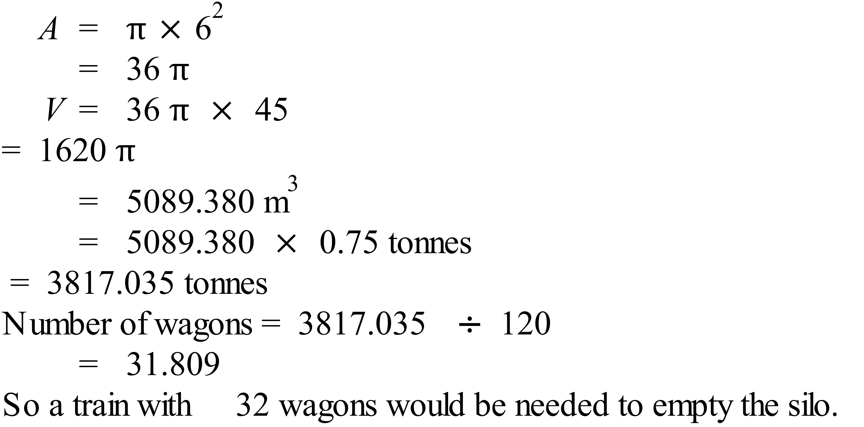 |  |  | B
 | 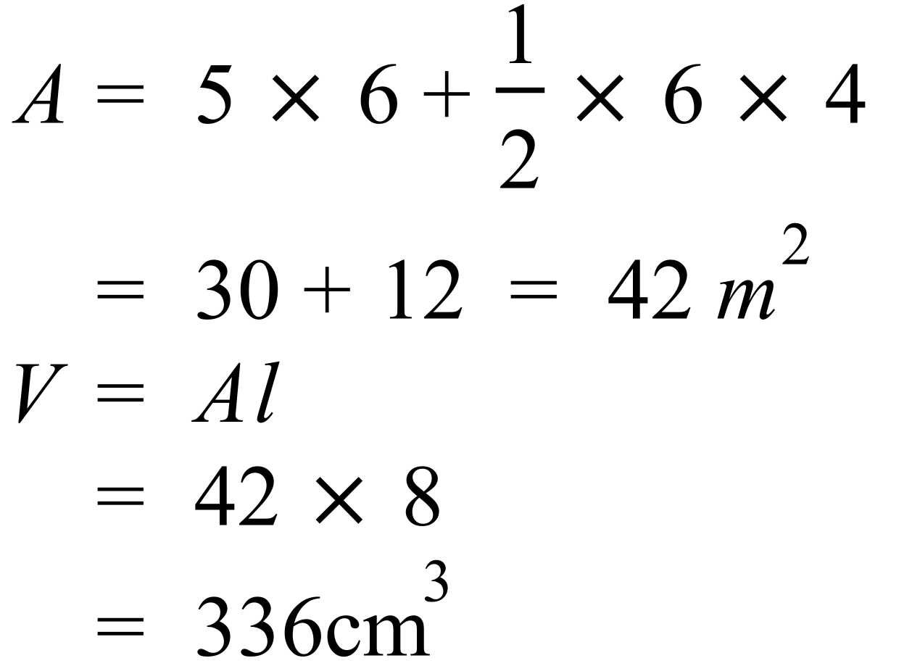 |  |  | D

Multiple Choice Answer Sheet
Volume and SA of Prisms and Cylinders
Name _______ANSWERS_______________________________
Completely fill the response oval representing the most correct answer.

1. A B C D
2. A B C D
3. A B C D
4. A B C D
5. A B C D
6. A B C D
7. A B C D
8. A B C D
9. A B C D
10. A B C D
11. A B C D
12. A B C D
13. A B C D
14. A B C D
15. A B C D

